Sherry & John’s Costa Rica Trip with Caravan Tours
February 11 – 20, 2010
(A few photos of animals are not my own)

Costa Rica with Caravan Tours Thursday February 11 -- Saturday February 20, 2010. Inclement winter weather delays our departure from Dulles on TACA Airlines a full 12 hours. After spending the night in San Salvador airport, we arrive San Jose, Costa Rica, at 10:00 Friday morning for start of day 2, February 12. Jose Sanchez picks us up at the airport to link us up with our group which has just come down from visiting beautiful Poas Volcano (back cover). We have lunch in the highlands while enjoying an indigenous dance performance.
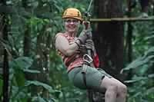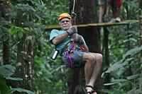
Jump ahead to our zip line adventure day 4, Sunday, February 14 (Valentine's Day). We look really cool, don't we? At least Sherry does. On the back cover are our fellow, courageous zippers. And also borrowed photos of Poas Volcano which we missed because of our delay. So sorry to miss it on such a rare, clear, sunny day. But so happy to be here with Elston Valentin, our guide, & Franklin, our bus driver. After lunch of sea bass & strawberry juice & the indigenous dance we return to San Jose.
After lunch we return to San Jose. Very tired, we rest at the Barceló Palacio, Aurola Hotel while others visit the National Museum of Pre-Columbian Gold. Later, I walk the city & visit the cathedral & museum. Sherry has a pina colada sin alcol & I a pilsener CR beer. For dinner, fish soup, & salad.
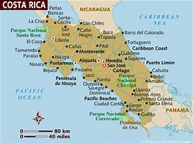
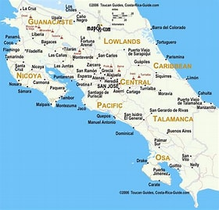

Our tour takes us first to the Caribbean Sea, then thru mountains to Fortuna, and then to the Pacific.
Early morning day 3, Saturday, February 13, I walk in the park across from the hotel. Its many monuments honor citizens with vision. Hearty breakfast of omelettes & rich coffee before we head NE across mountainous Braulio Carrillo National Park to Tortuguero & the Caribbean Sea. We pass thru seven ecosystems & visit a butterfly garden & banana plantation.
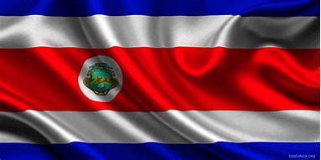

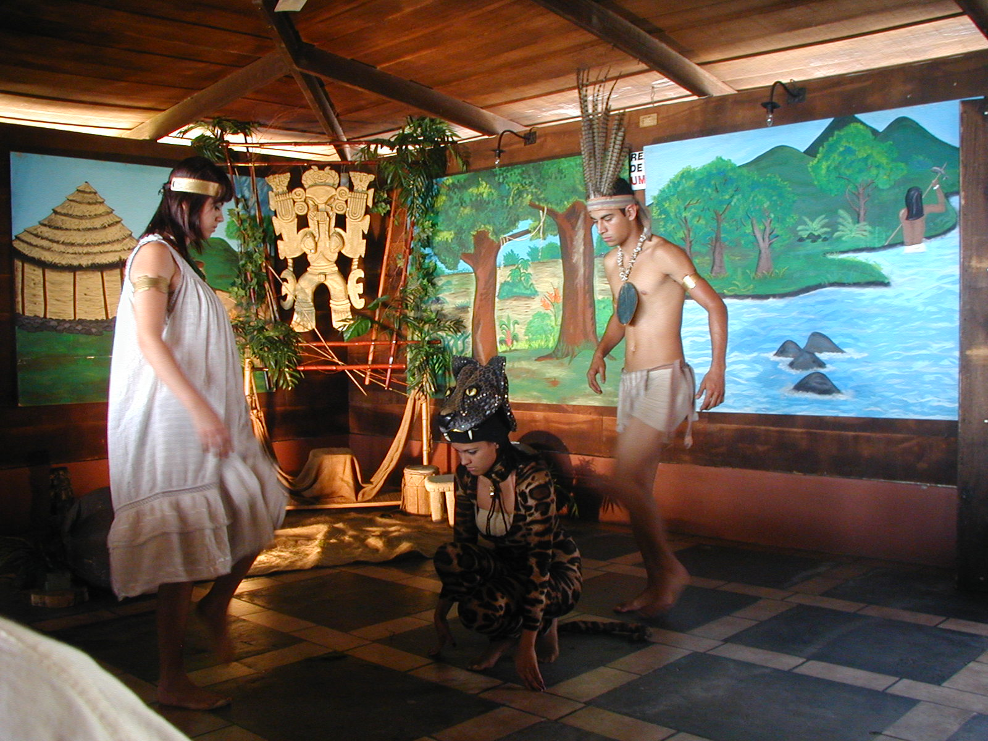

Day 3 Saturday is packed. In the end, we are welcomed to our Aninga Hotel cottage after a long day of enchantment. Tortuguero where sea turtles lay their eggs. Blue morpho & monarch butterflies. Tropical flowers (the bright red heliconia). Rhinocerous beetles. Brahman cattle with egrets. Howler, spider & other monkeys. Sloths. Crocodiles & alligators. Tropical birds. Coconut milk. Poro trees. Tarpon & sea fish. Del Monte banana plantations. Papaya. We glide thru the jungle canopy on a rainforest aerial tram with spectacular views of primary rainforest & on the Rivente Sol river cruise with Ray Brown. We pass thru Elston's hometown of Guacimo.
Day 3 Saturday is packed. In the end, we are welcomed to our Aninga Hotel cottage after a long day of enchantment. Tortuguero where sea turtles lay their eggs. Blue morpho & monarch butterflies. Tropical flowers (the bright red heliconia). Rhinocerous beetles. Brahman cattle with egrets. Howler, spider & other monkeys. Sloths. Crocodiles & alligators. Tropical birds. Coconut milk. Poro trees. Tarpon & sea fish. Del Monte banana plantations. Papaya. We glide thru the jungle canopy on a rainforest aerial tram with spectacular views of primary rainforest & on the Rivente Sol river cruise with Ray Brown. We pass thru Elston's hometown of Guacimo.
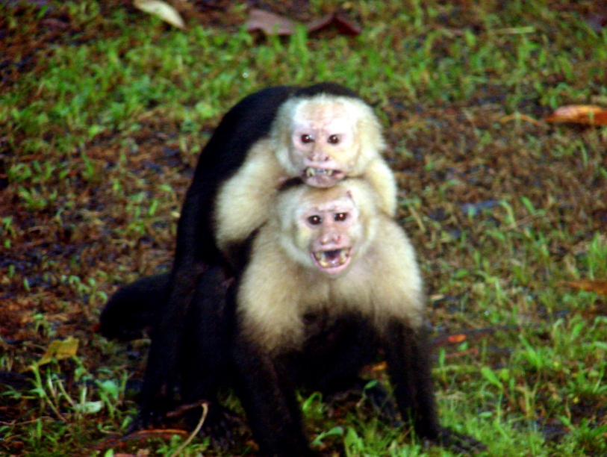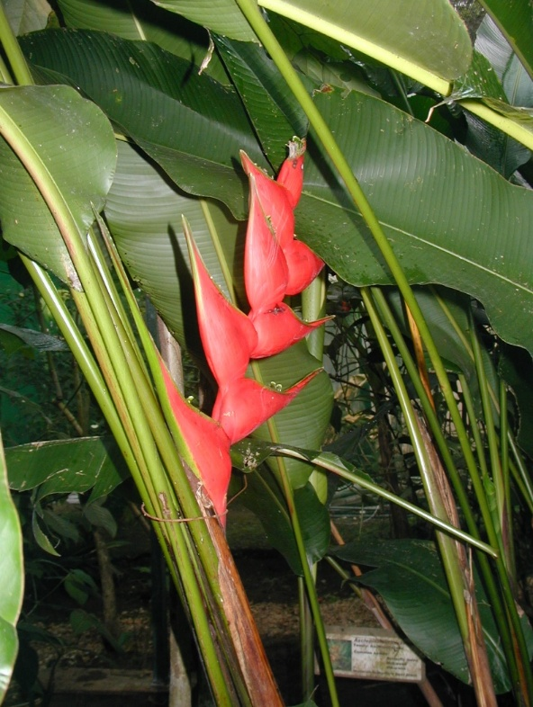

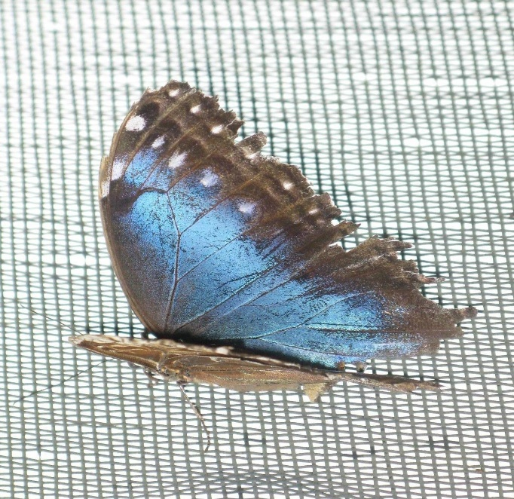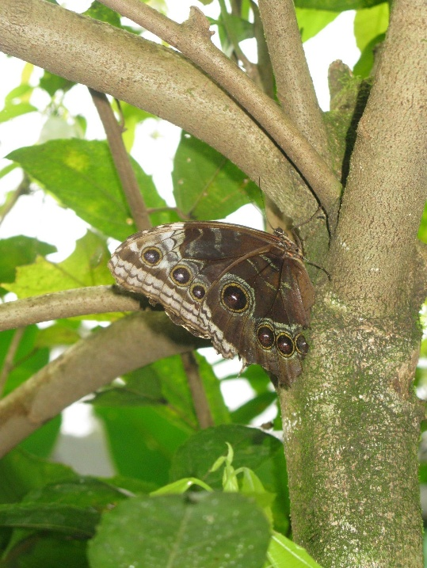
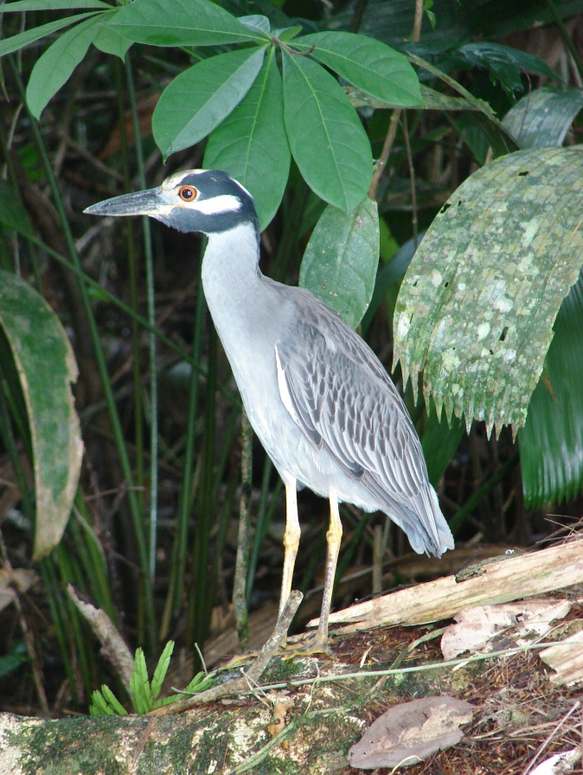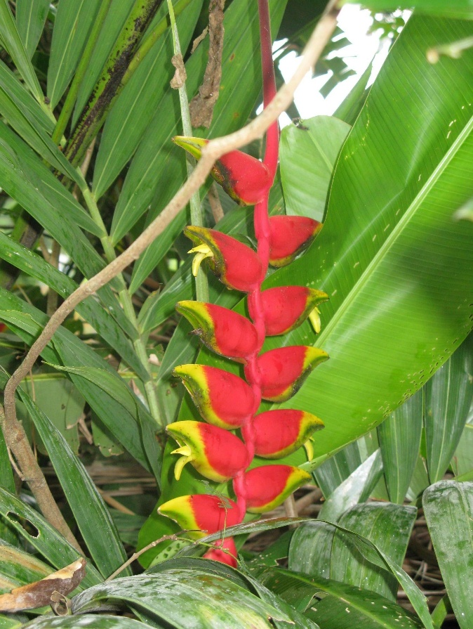

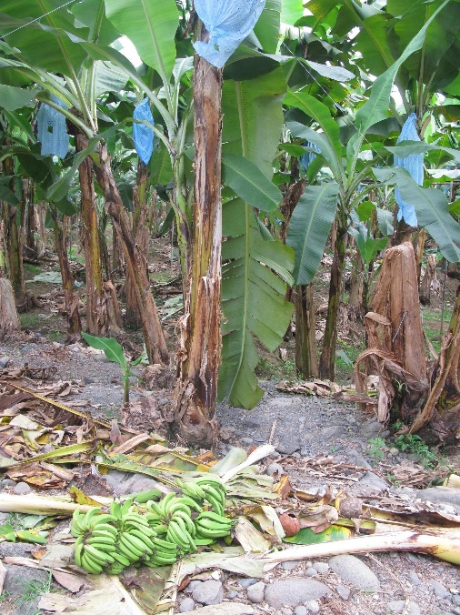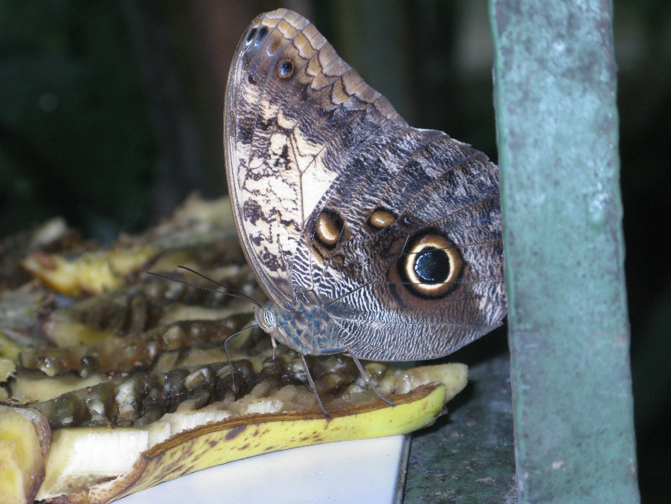

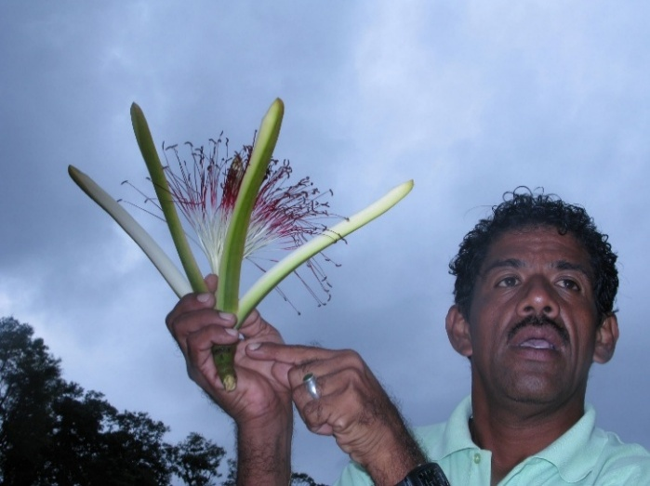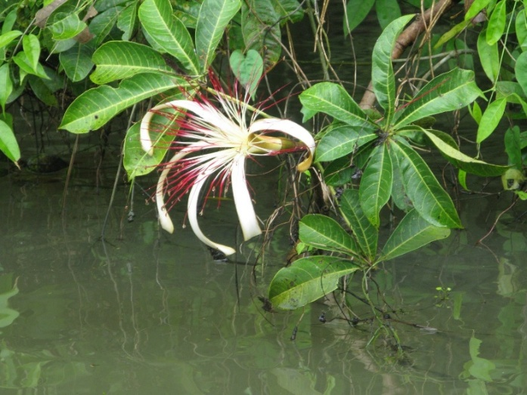

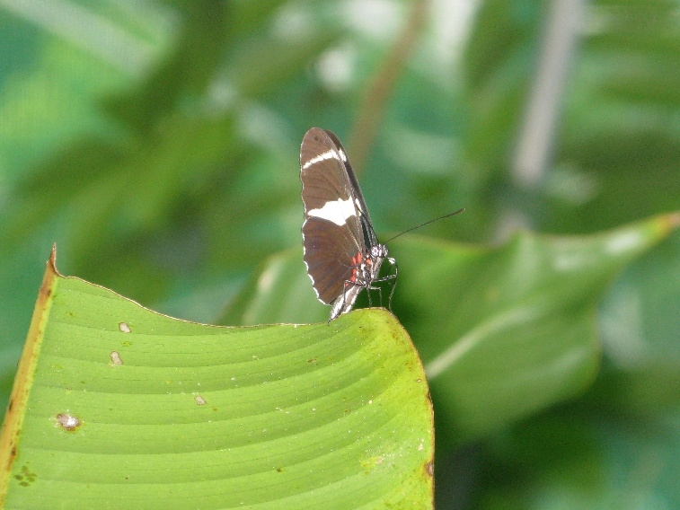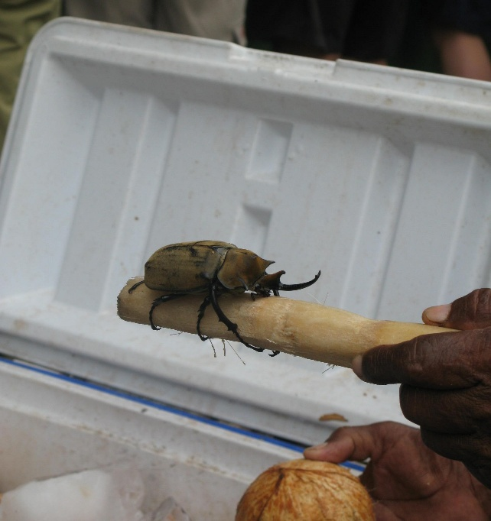

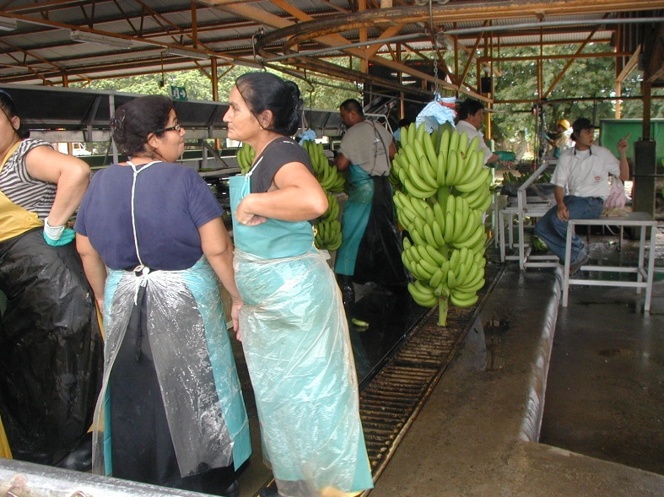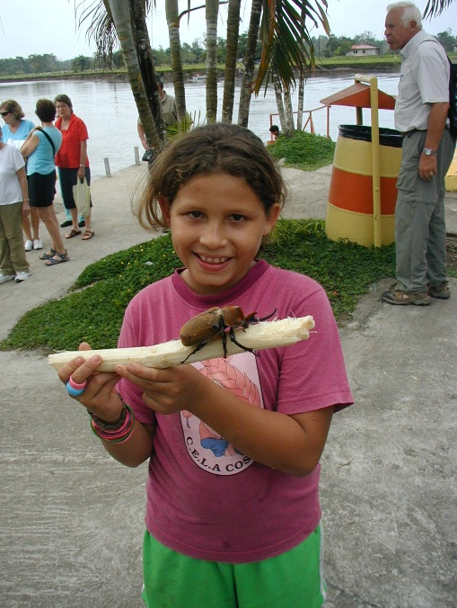
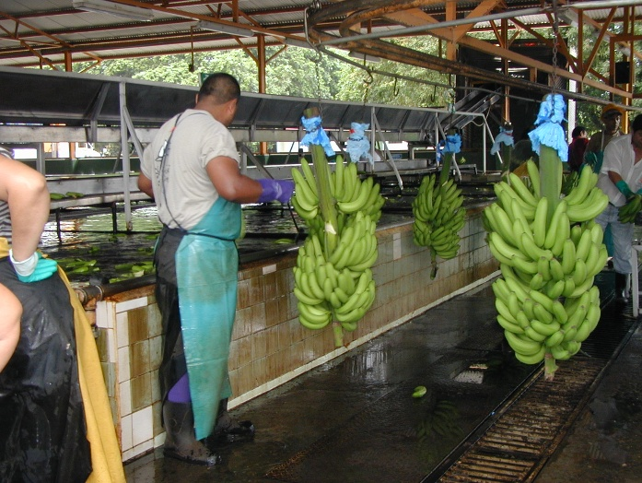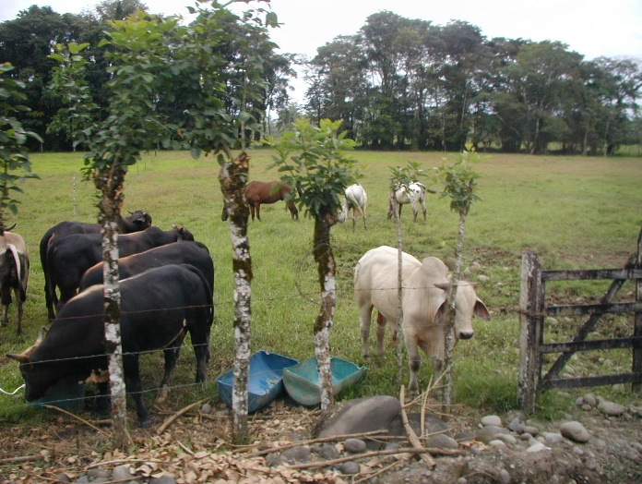

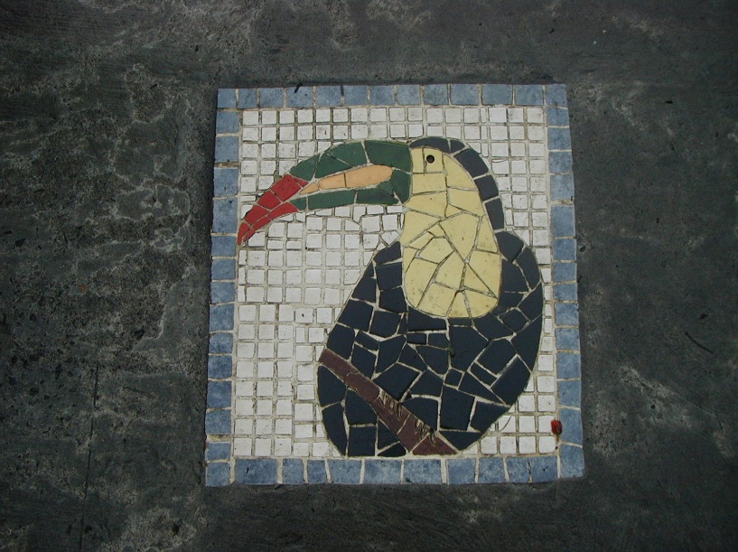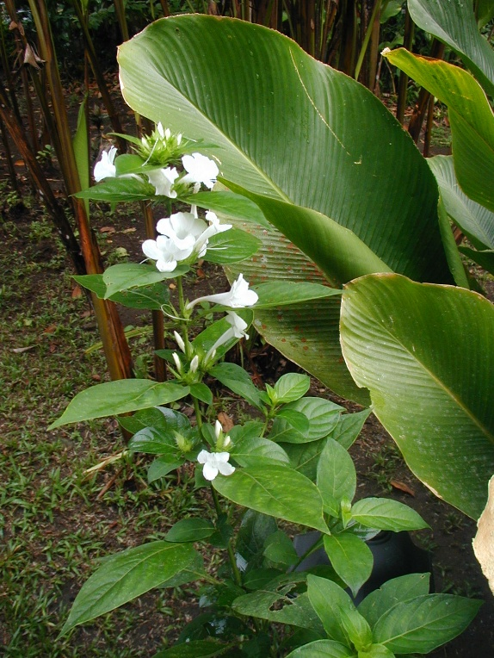

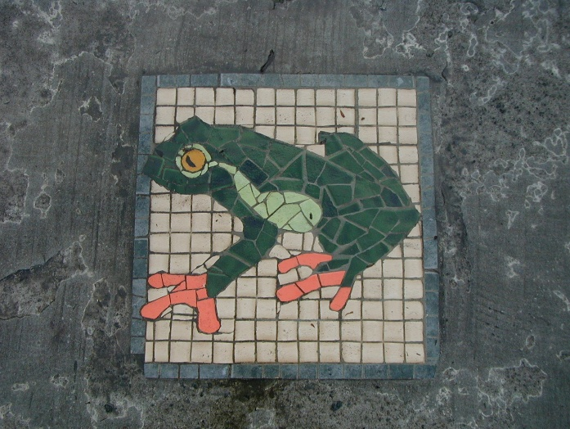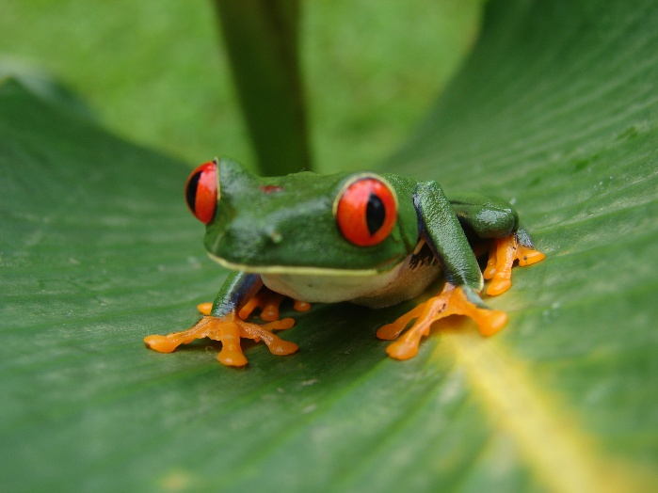

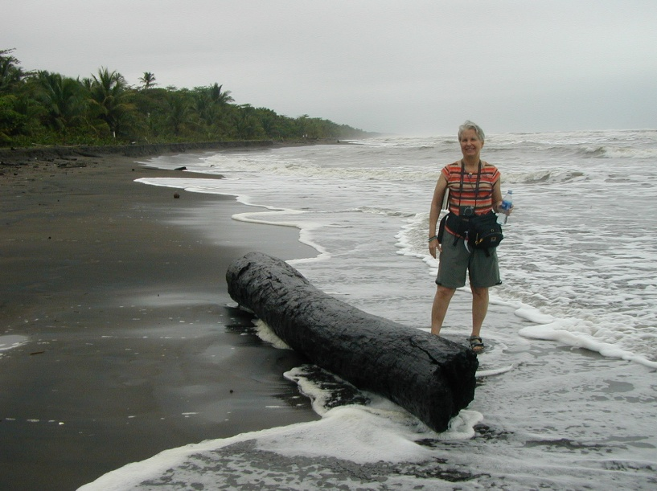
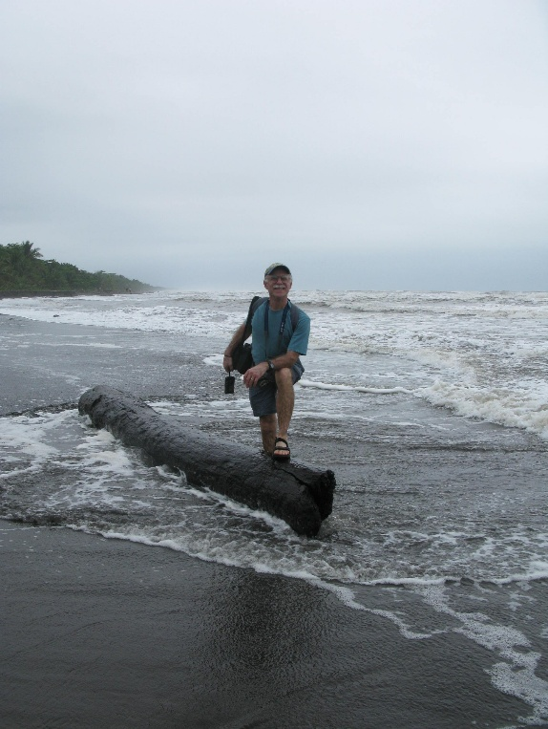

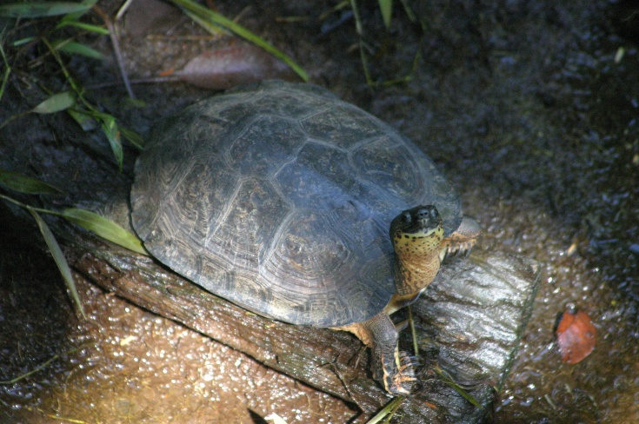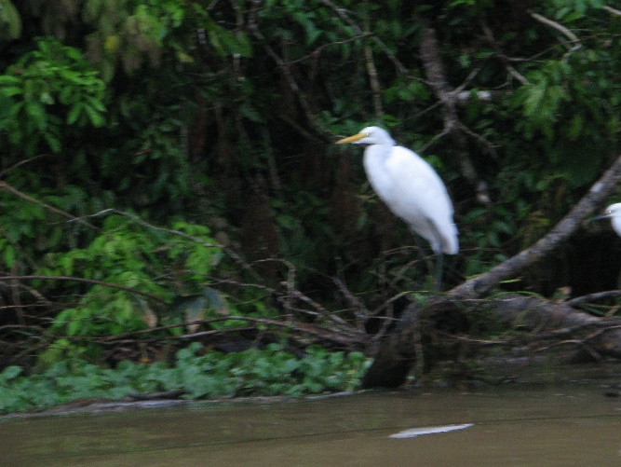

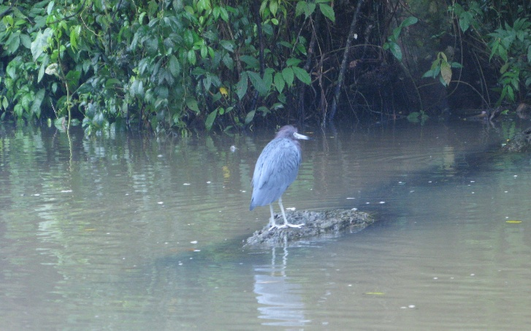
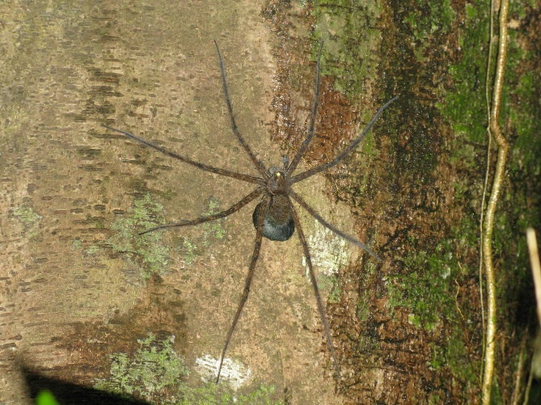

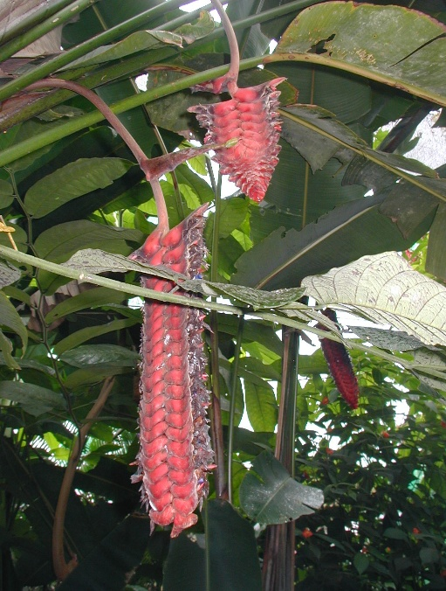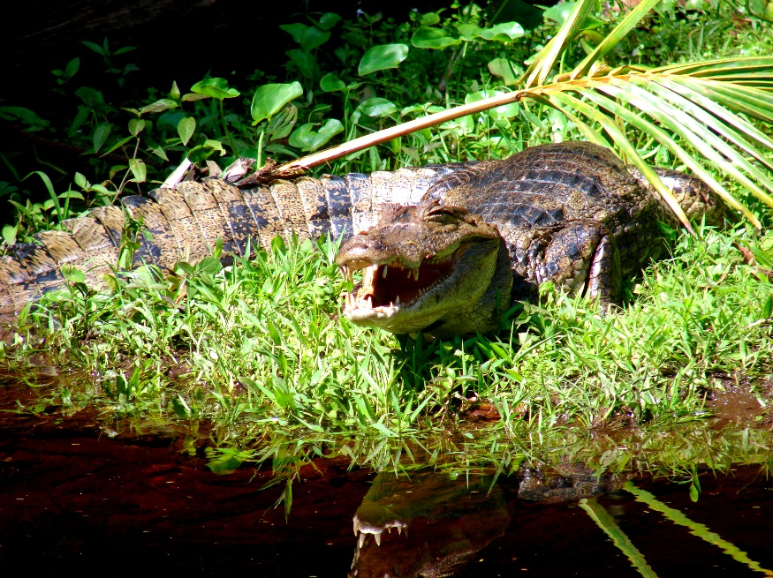

Rain & tin roofs at our Aninga cottage. Lovely sleeping. We begin day 4, Sunday, February 14, Valentine's Day, to explore Tortuguero National Park (since 1975). Also, we explore the Rio Penitencia into Nicaragua. So rich in fauna & flora. We meet so many wonderful people on this Caravan Tour, including Margaret & Joe from Milwaukee posing on one of the six suspension bridges we cross to see the lush rainforest -- actually on day 7, Ash Wednesday, February 17.
Two-meter-long caimans. Snow & great egrets. Tiger herons. Ring kingfishers. Tiny red-eyed tree frogs. Strawberry poison dart frogs. Royal palms. Epiphytes (not parasites) whose roots grow to the water. The beautiful aquatic pachira flower which I videotape as Ray explains its parts. The green Jesus Christ lizard. Iguanas. Bats essential to fertilization. Dethroned monkeys. Feminist Jacana bird - the male takes care of nest & young. Green ibis. Mimosa tree that flowers only at night. Boat-billed heron. Big spider with eggs. White-faced monkeys. Villagers eat snook & red snapper. Vultures. Osprey kills fish by suffocation - putting the head in the direction of flight. Great owl butterflies. The rhinocerous beetle. Great potoo. Colorful keel-billed toucans.
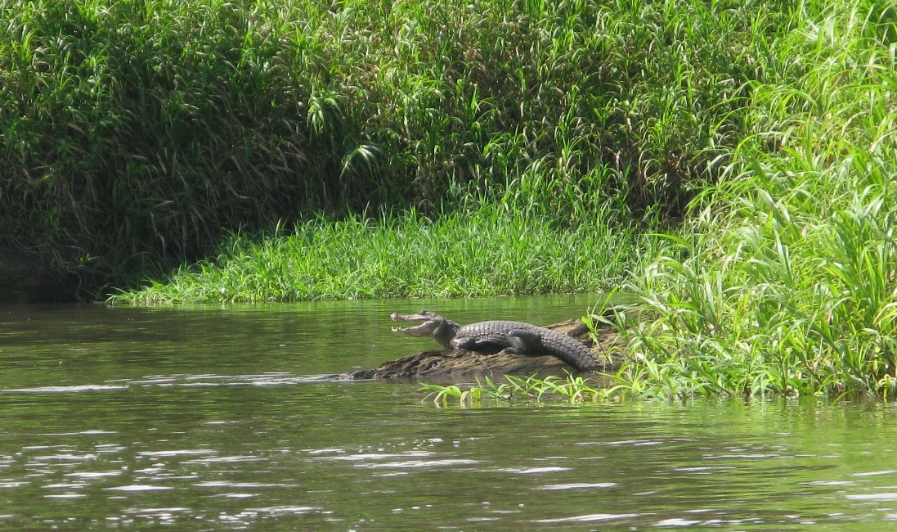

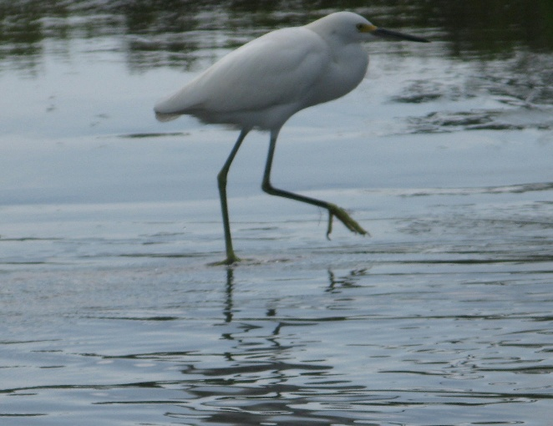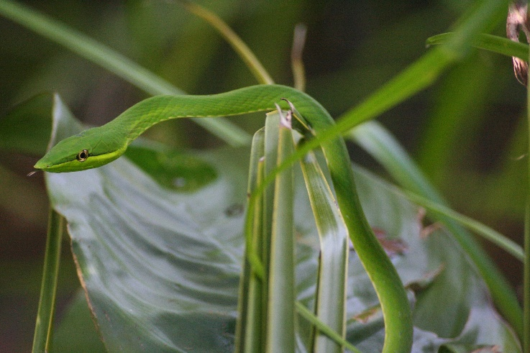

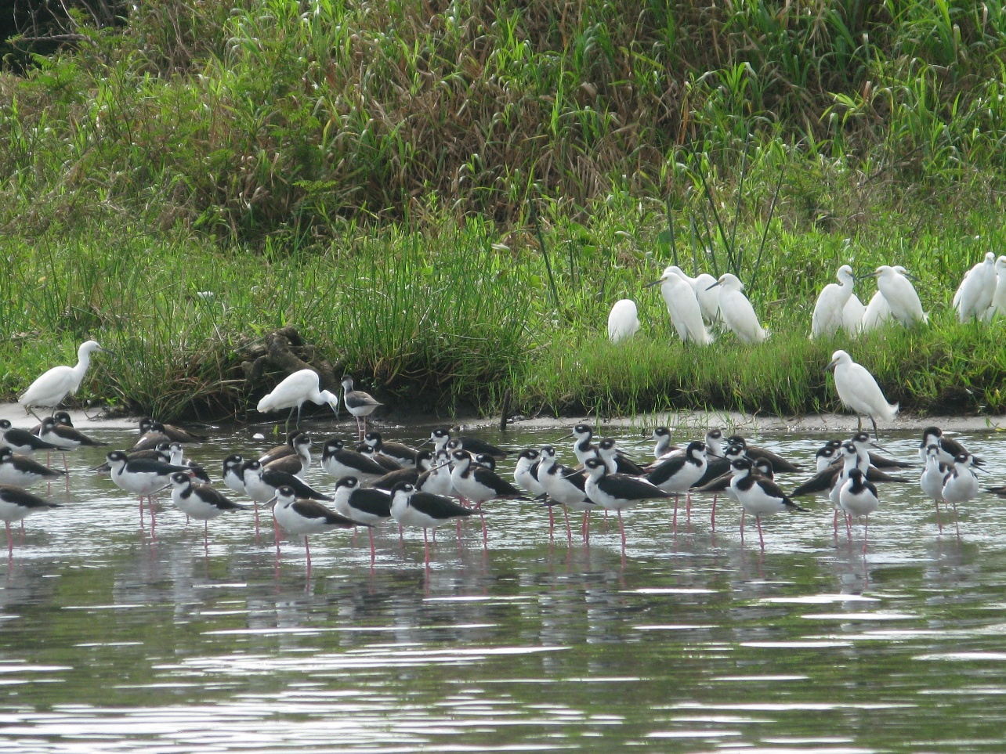

We meet so many wonderful people on this Caravan Tour, including Margaret & Joe from Milwaukee posing on one of the six suspension bridges we cross to see the lush rainforest -- actually on day 7, Ash Wednesday, February 17.
Day 5, Monday, Feb.15, Presidents' Day, we leave Aninga Lodge (type of bird). Up at 05:00 to listen for howler monkeys. Very loud. Rained all night. So wonderful. After breakfast, Ray takes us back to our bus on a two-hour launch ride.
Many iguanas & egrets. Elston explains the toxic red dart & curare poisoning. Expressions in Costa Rica: Con toda la plata & pura vida. After lunch & dance performance we are off to a Dole pineapple plantation.
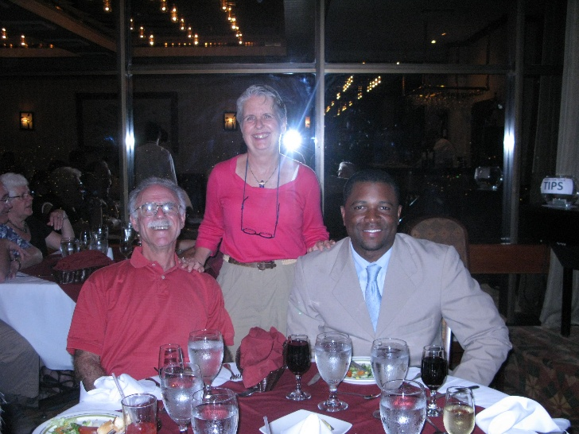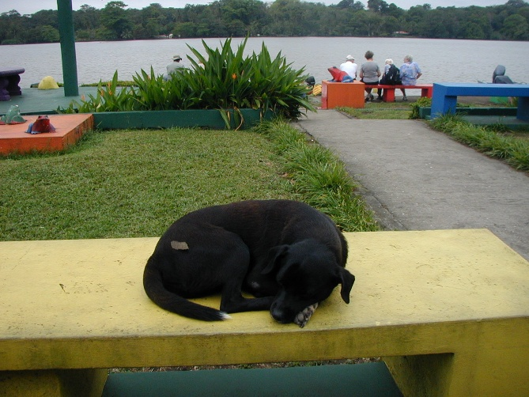

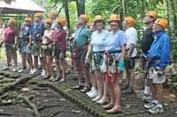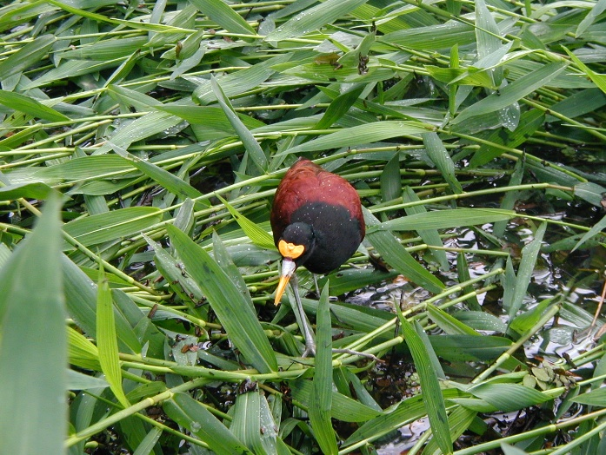

Elston gives the ladies a valentine gift of the bird of paradise (halaconia). He shows us ilan ilan, a fragrant plant used in Chanel # 5, cacao coco bean, & the medicinal noni fruit. The boat ride is beautiful. Egrets. The black & white aninga bird.

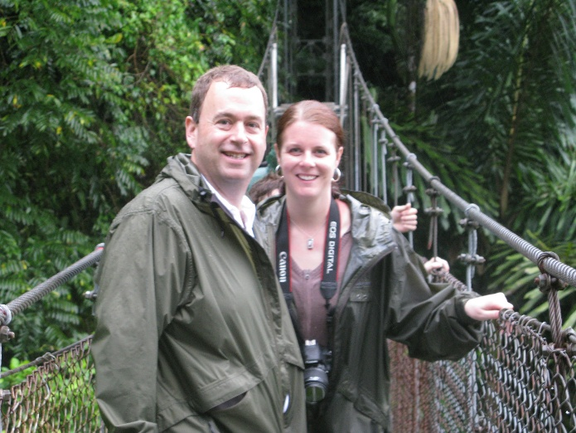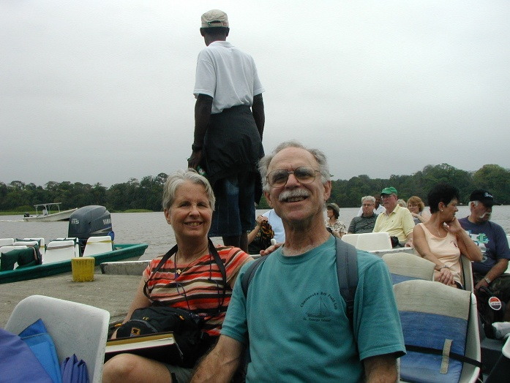

Barely make it on the shallow California river. Many scampering monkeys & their young. Back on the bus, we head West to La Fortuna via Guacimo, Elston's home with his beautician wife & daughter & son. Kids are cute in white tops & blue bottoms.

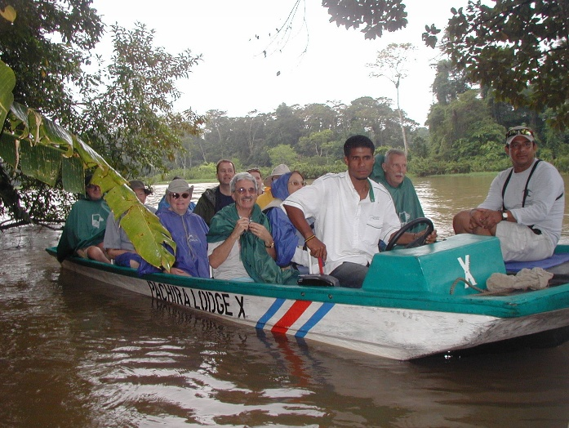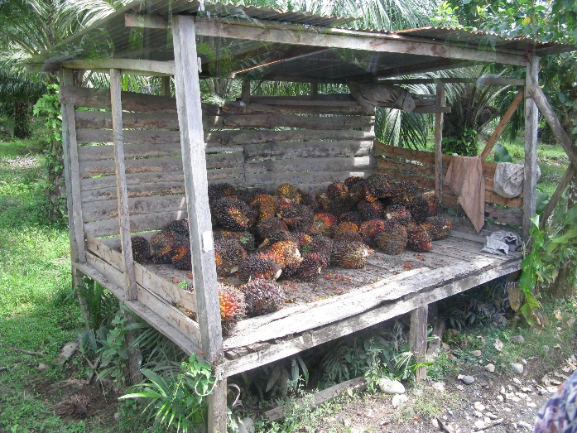

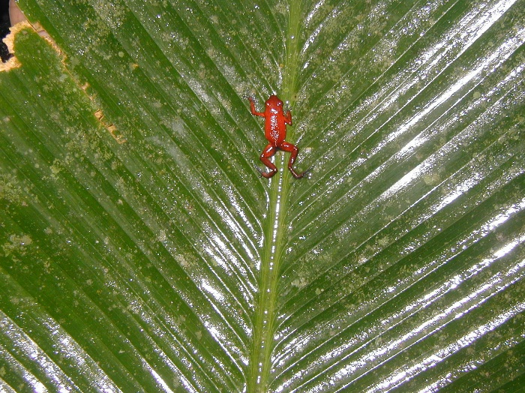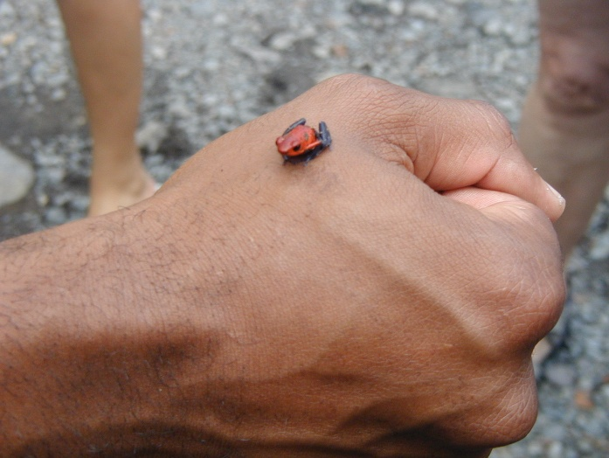

The yuca plant (cassava, manioc) has six or seven roots - distinct from yucca. Teak farms requiring 10-12 years for maturity & harvesting. Orange plantations of the Valencia variety. Lots of cows. Rich volcanic soil with oxygen, iron & other minerals. On our incredible morning cruise on the Rio Frio, we see many iguanas in the trees, a beautiful red & black tanager, howler monkeys, caimans, many migratory birds, mangroves, swallows, cara-cara, roseate spoonbills at the border. (See p.15 of guidebook.) And the sign for Nicaragua as we are on the Rio Frio in the Cano Negro going north to just 300 feet within the Nicaraguan border. Every bit worth the 2-hour trip here from La Fortuna & back! Good C.R. beers. Bavaria (dark), Imperial, Pilsener. After lunch & dance show by 11 to 14-year-old dancers, we leave Los Chiles to return to La Fortuna. Enjoy seeing laundry out hanging. No dryers. A huge kapok tree.
Man on horseback. Laborers in fields picking beans (frijoles). Thatched rooves. Tin rooves. Mom & Pop grocery stores. Woodwork displayed at the Heliconic restaurant - mahogany (cacoba), teak (teca). Wide cell phone use.

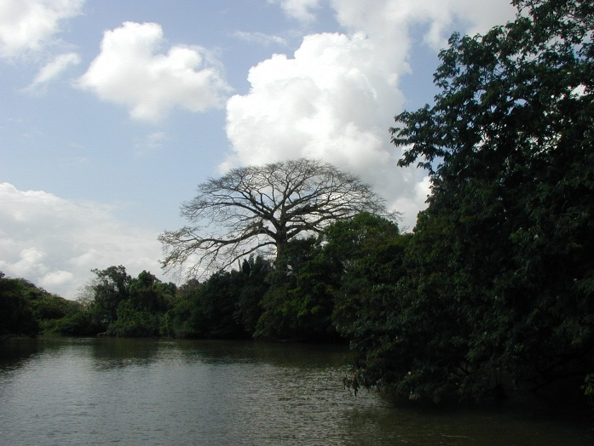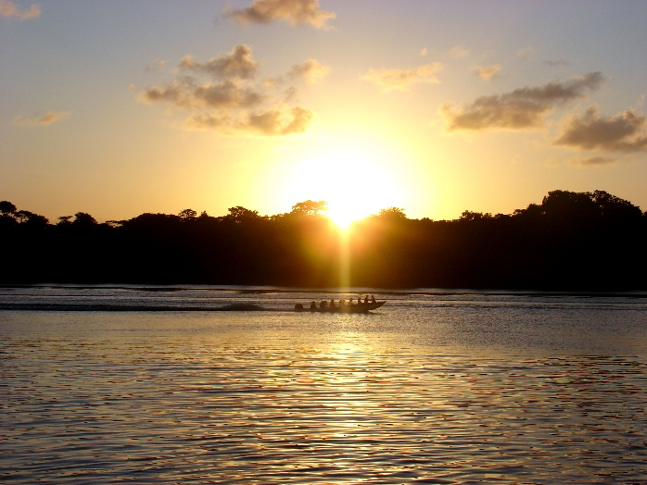

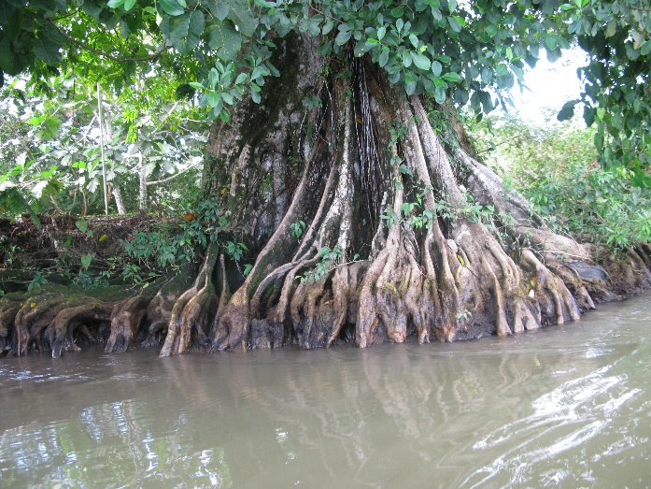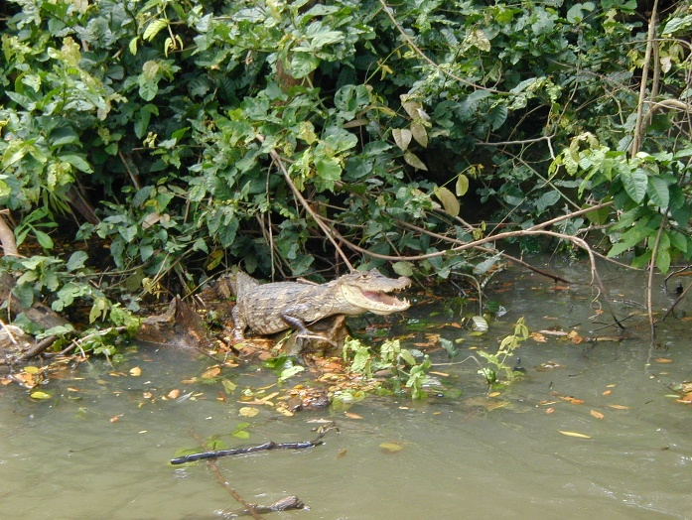

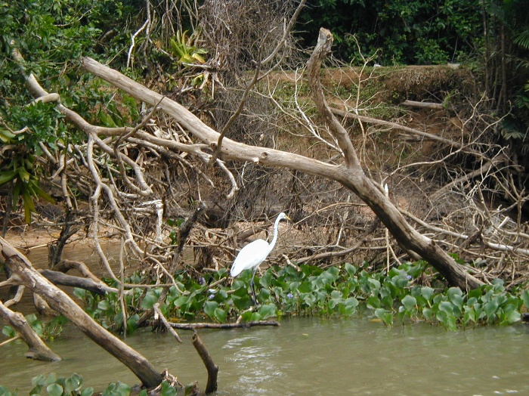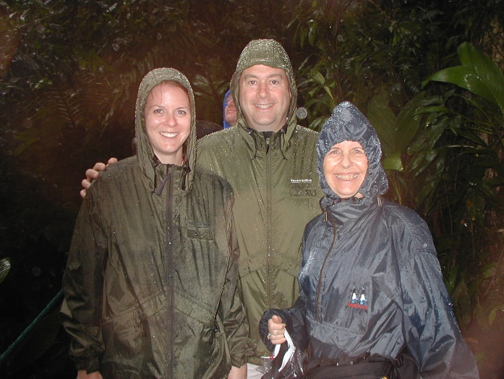

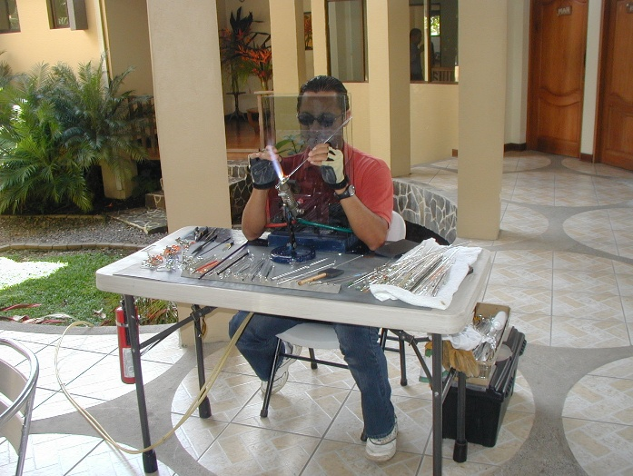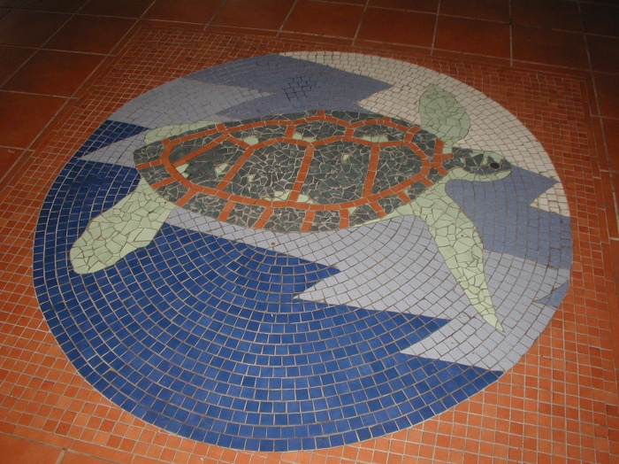

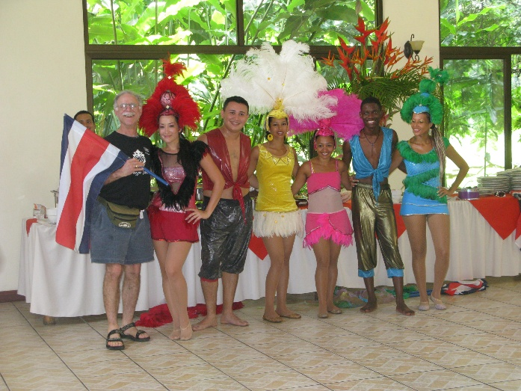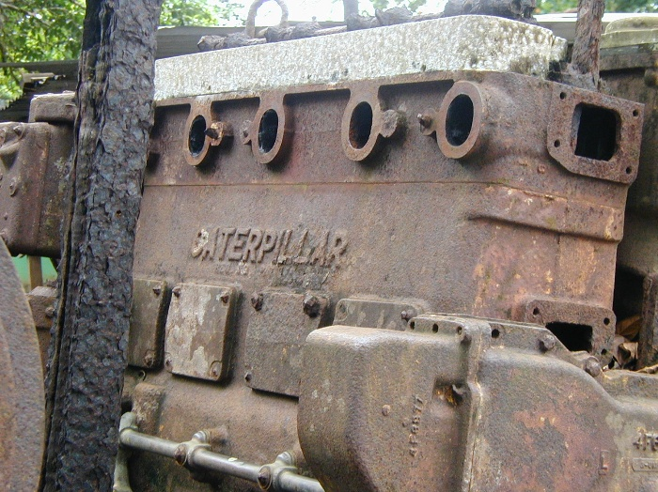

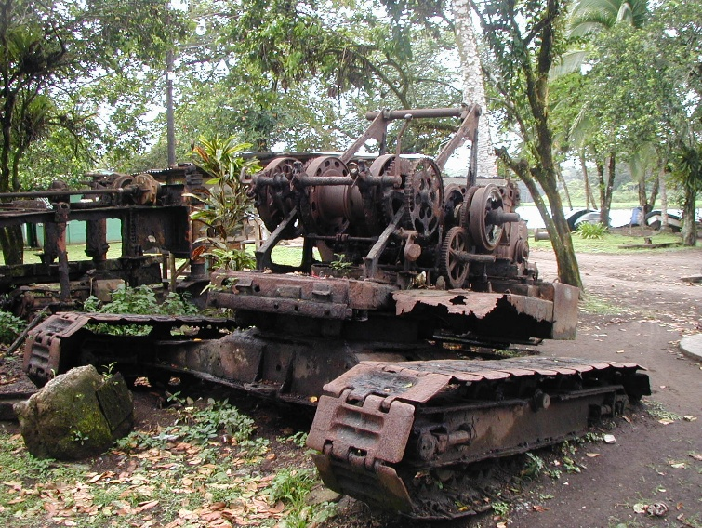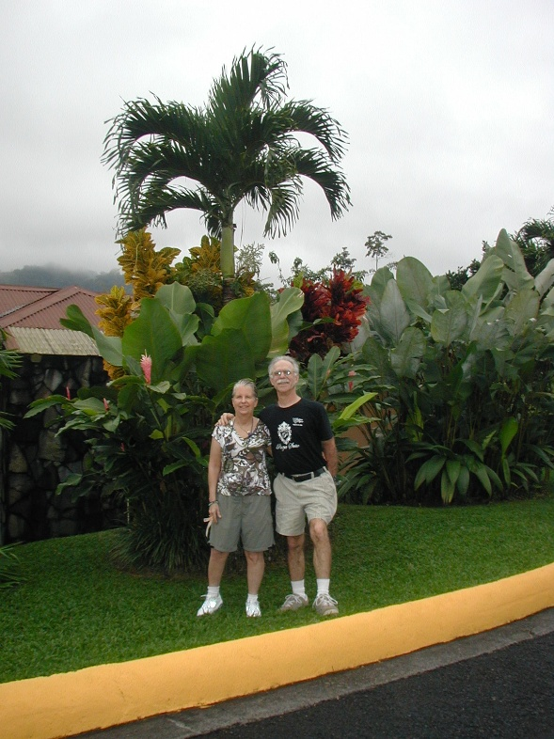

We buy little grass frogs for the girls from the glass maker at the Sebo restaurant. Many trucks. Many bicyclists in the small towns. The Corsicana Plantation (Finca Corsicana) - home of Collin Street Bakery (fruitcake).
After passing through La Fortuna, we arrive at the Arenal Springs Hotel at 17:30. The Arenal Volcano is not to be seen yet. It's been a long day of travel with nice breaks. We learn a lot about pineapples. Sherry & I walk after dinner & we see an armadillo. Then day 6 Tues. Feb. 16, 2010 by 08:30, we are driving to Los Chiles on the C.R.-Nicaragua border where we will do a slow rafting trip on the Rio Frio to see nature. Sherry stays behind with several others. But then they will join us later at the Baldi Termae (Hot Springs). On our drive to Los Chiles, lots of pineapples on the side of the road. A sugar cane processing plant refinery (Ingenio) where liquid is extracted from the cane, then boiled, and finally turned to crystallized sugar.
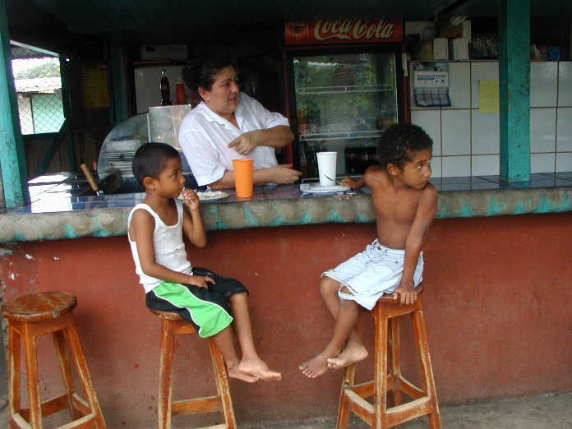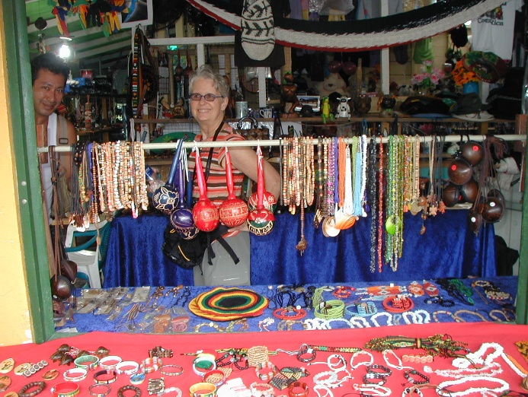

"In the northern zone of Costa Rica, more specifically in the adored village of La Fortuna de San Carlos, lies the majestic Volcano Arenal. Tucked away in the province of Alajuela is an authentic tropical paradise, perfect for relaxation and rest." It is the Baldi Hot Springs Resort & Spa - three hours from San José. Christine & Lynnell, the young & vibrant ones on our trip. They enjoyed doing everything & were fun to be with.
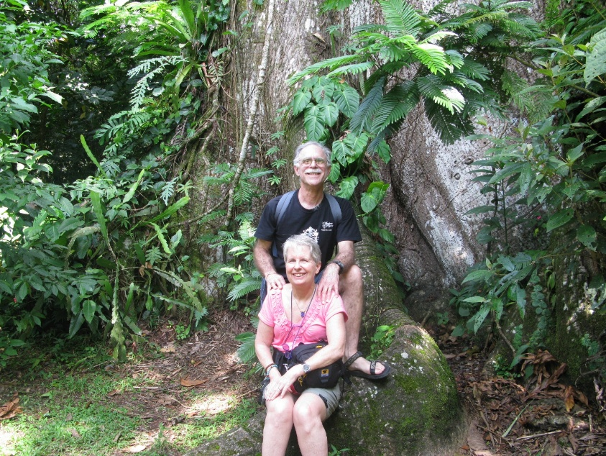
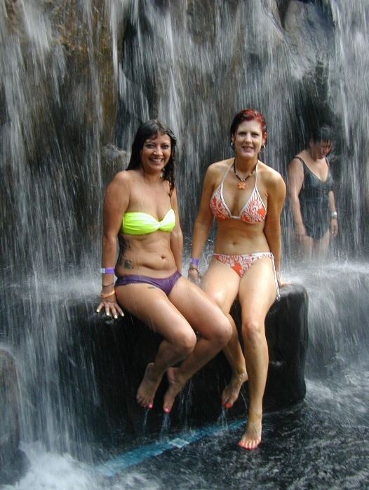

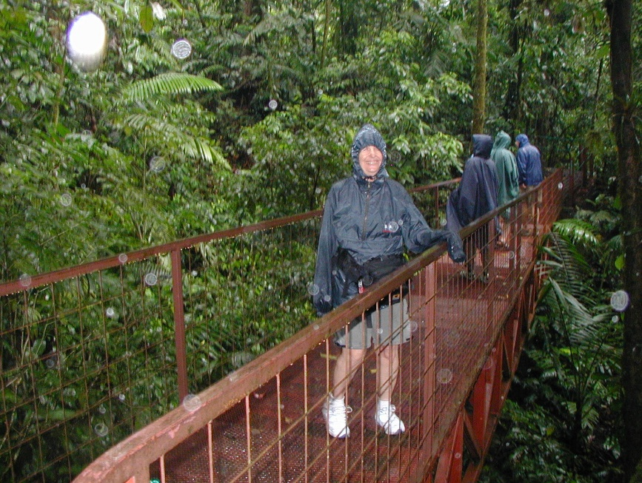
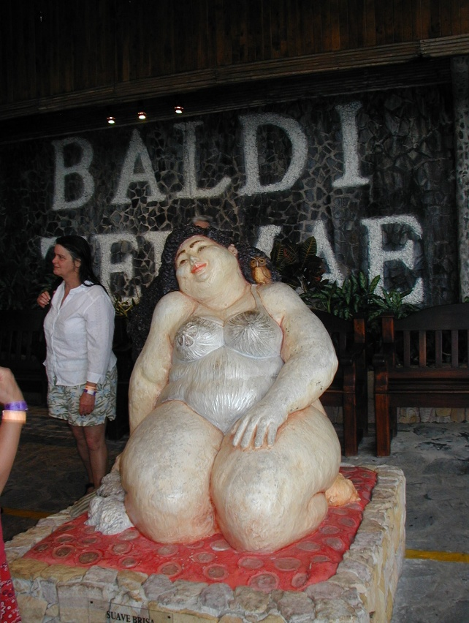On day 7, Ash Wednesday, February 17, Sherry is dressed in her poncho walking across one of the many suspension (hanging) bridges over the rainforest.
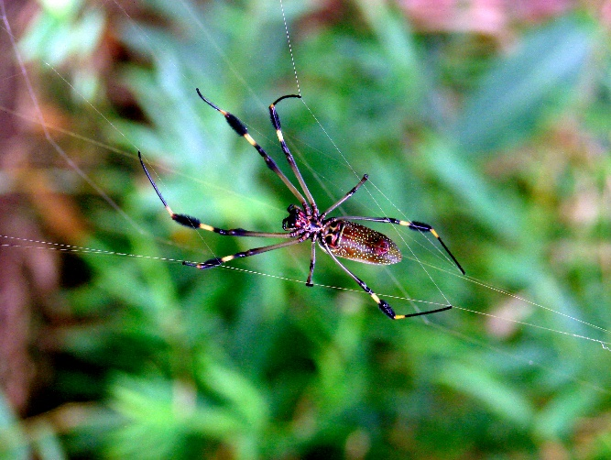
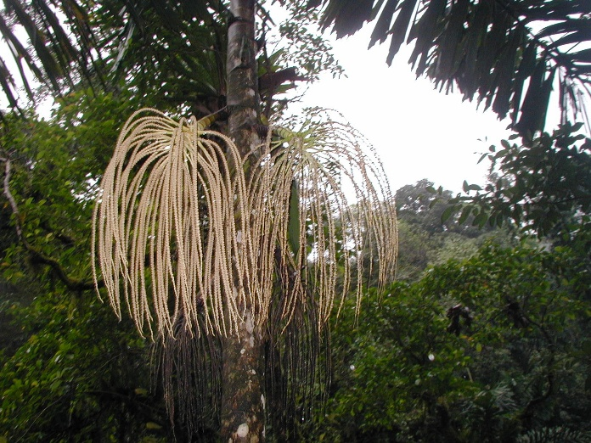
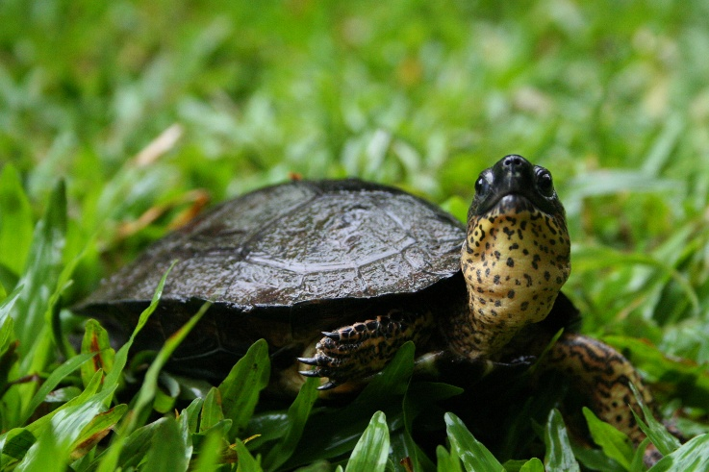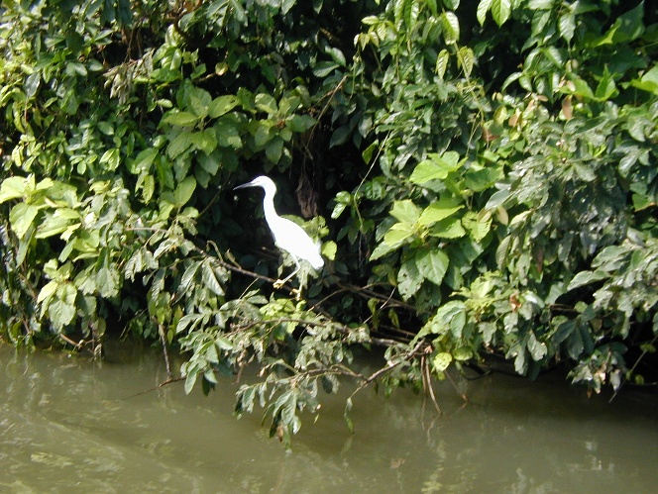
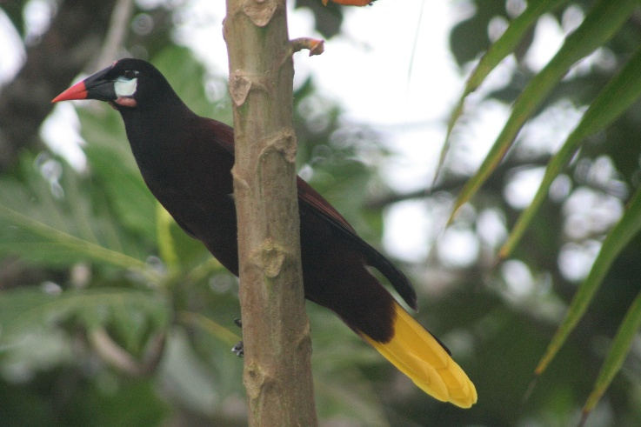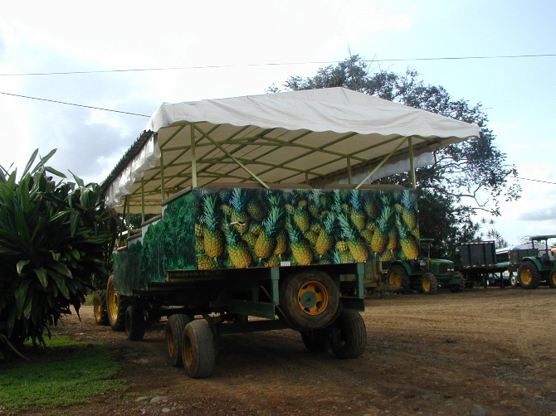

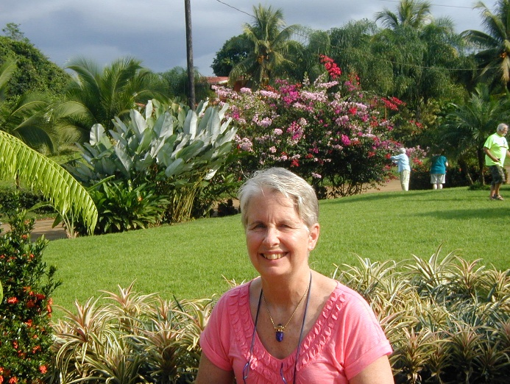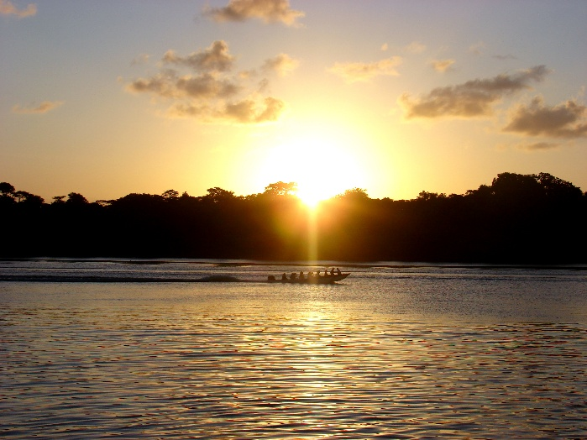

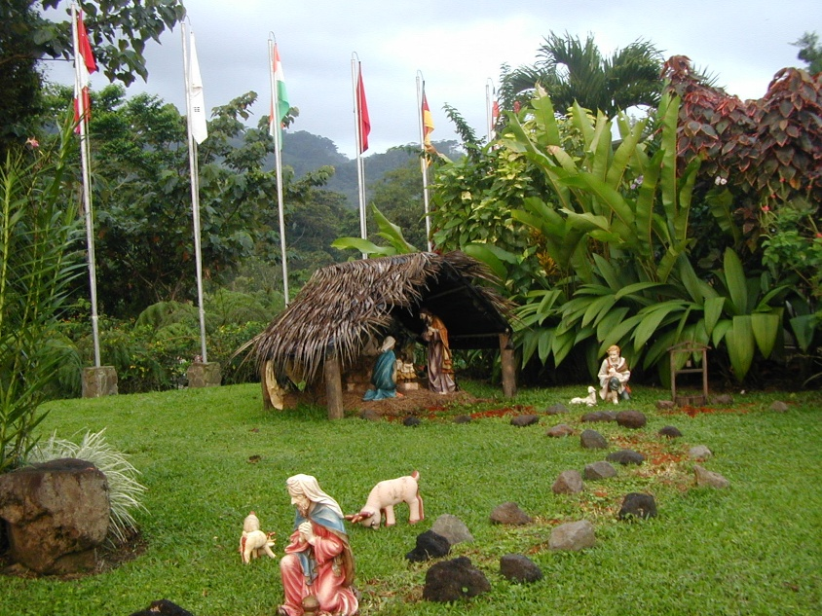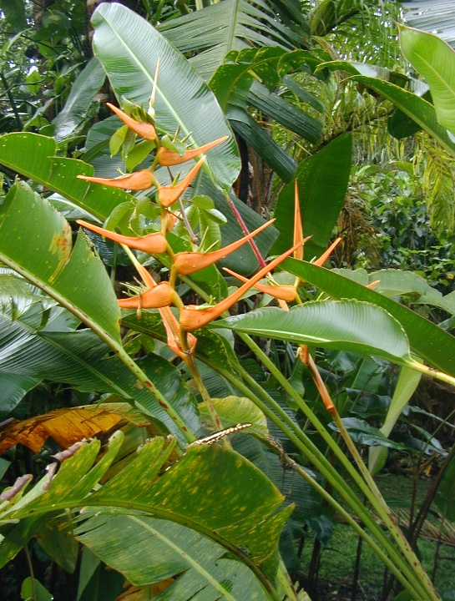

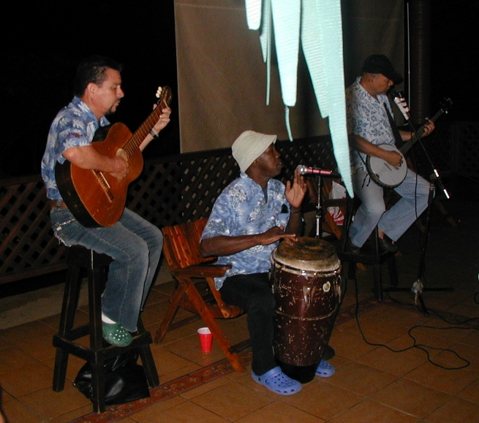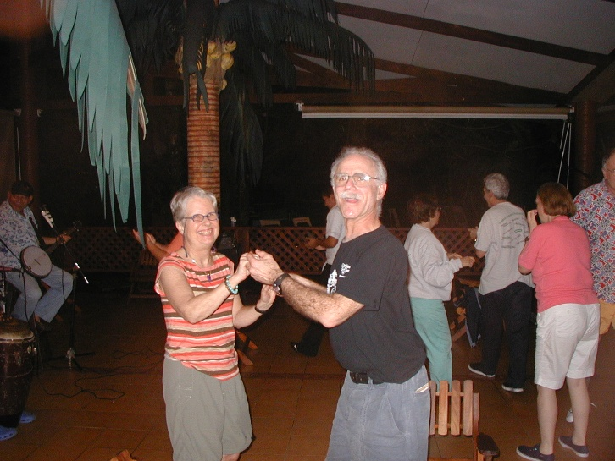
What a full, rich day! At 17:40 we are back at the Arenal Springs Lodge. "Solo Bueno." Dinner at 18:30 with Joe and Margaret, then a walk, then to bed, to start at 06:30 with luggage on day 7 Ash Wednesday Feb. 17, 2010. Rained heavy during the night. No Arenal sighted yet. Morning drive to walk one-hour, 1.9 miles, 300-meter climb over six suspension & nine stable bridges over rainforests. Pit viper & eye-lash viper. Walking tree. Thick vegetation. Rainy. Wear ponchos. Very eco. Afterwards, we drive around man-made, hydro-electric Lake Arenal & Sangregado Dam & head north-west to Liberia, in the Province of Guanacaste, & to J.W. Marriott on the Pacific, near Tamarindo. Lunch on the way at Plaza de Café - Children of the World Foundation. Continental divide. Dec.-April is the dry season in Guanacaste, the driest region of C.R. Watch the eco-systems change. Prices of crafts are fairly expensive in C.R. as compared to Guatemala. In Guanacaste, windmills are privately owned. Grasses. Cattle. Haciendas. Rice. Irrigation canals. Pampas.
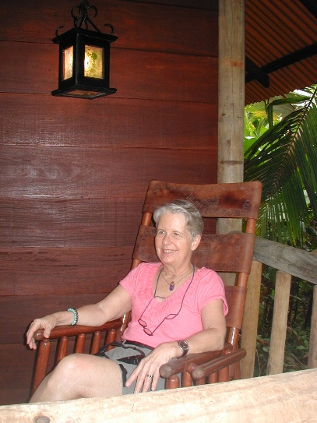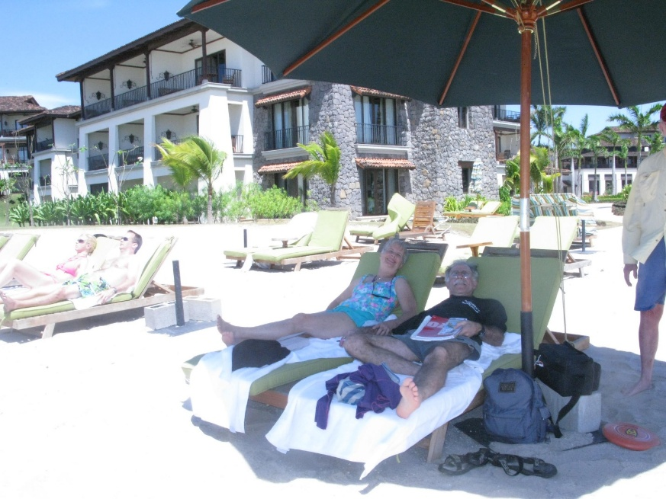
So different here. Rich coast. Rich interior. Volcanoes on the Cordillera. The road we are on is Route 1 (Pan American Highway) which stretches from Alaska to Tierra del Fuego. I buy two blends of espresso.

On day 8 Thursday Feb. 18, 2010, at 11:45, we are lounging on the beach on the Pacific. Earlier, Elston pointed out wood storks high up, orange-fronted parakeets, parrots, & orioles, rufus-naped wrens, grooved bill ani, hummingbirds, black-headed trogon, iguanas, spiny spring cedar trees, acacia trees with protective ants & wren nests (symbiosis), &, very importantly, turtle nests with fresh tracks. During a 2-3 hour process, the female arrives & departs with high tide & lays 100+, ping-pong size eggs. A variety of photos follow with no particular order - the tropical rainforests with flora & fauna & the beautiful beaches around the Marriott.
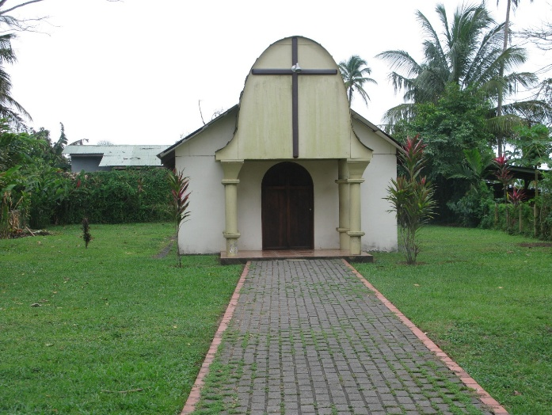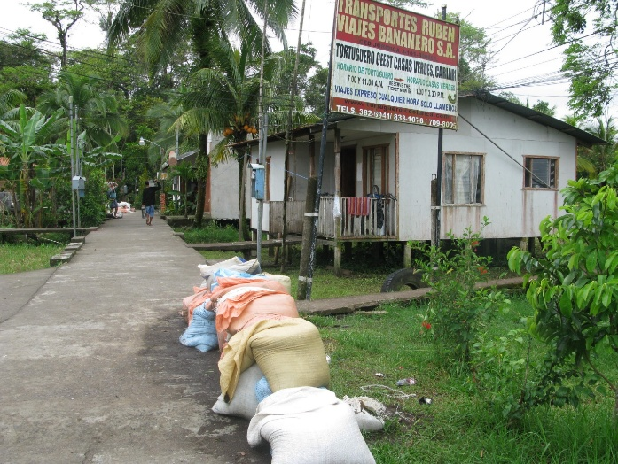

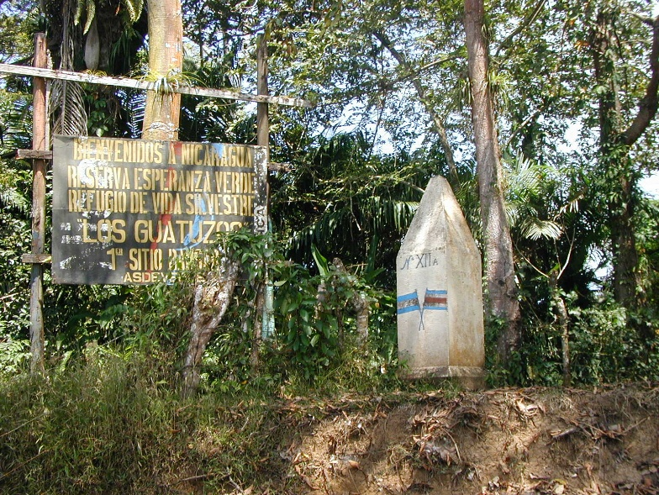
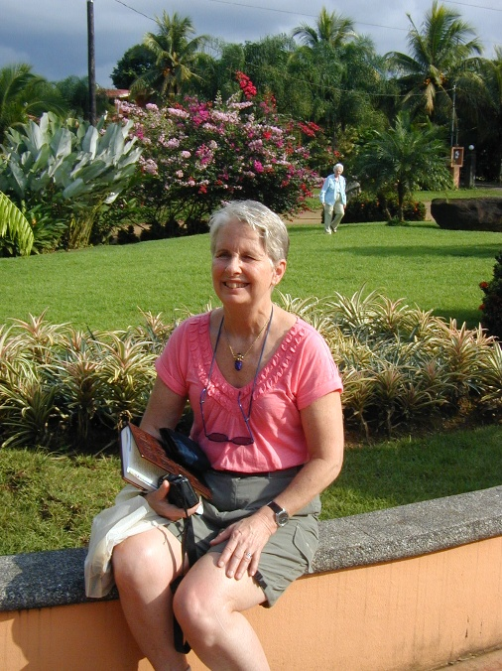
In our nature excursion, Elston explains the chahas disease. A mosquito leaves excrement & eggs, hibernates 10+ years, & causes enlarged heart & death. One Costa Rican doctor / astronaut thinks the cure is in the tree whose trunk processes chlorophyll photosynthesis. But the juices for the cure can only be procured by extraction at 0 gravity. Clearly, a task for an astronaut.
At the Marriott, we spend time on the beach -- sunning, swimming, reading; and wading in the pool for happy hour. We talk with Diane & Jerry, who has ties to Chincoteague & Assateague & who knows Billy Beebe. Both nights Sherry & I sit on the beach listening to the waves of the ocean & watching the brilliant stars light up the sky. The town of Tamarindo is nearby.
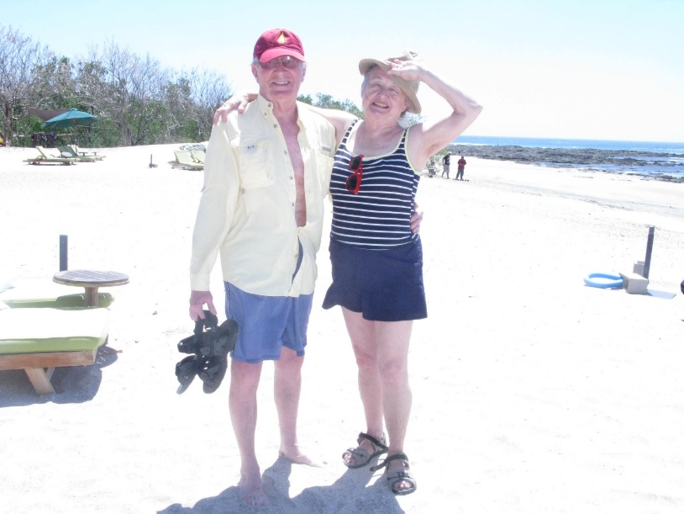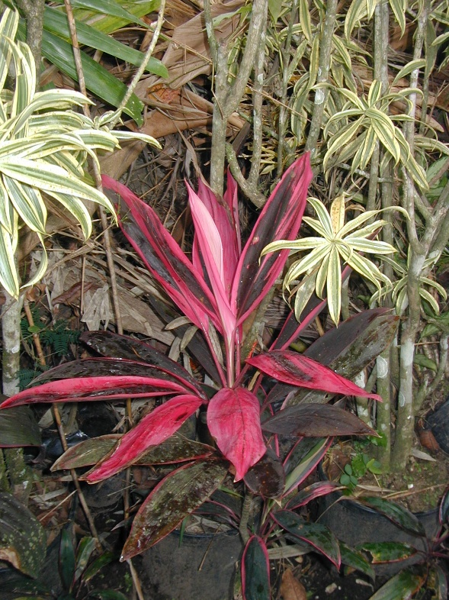

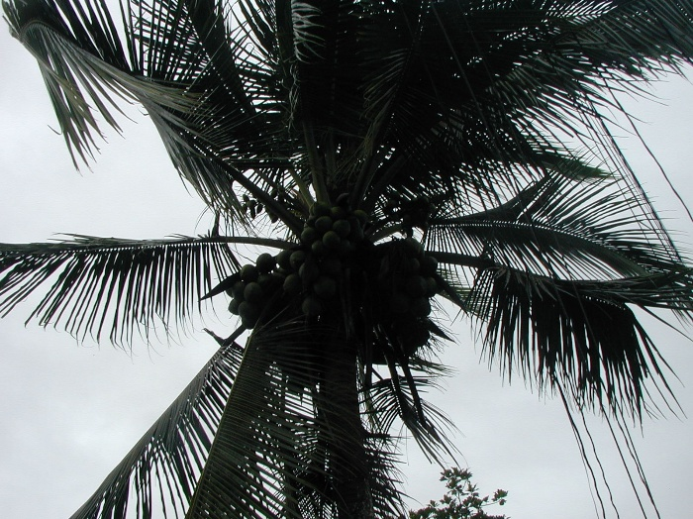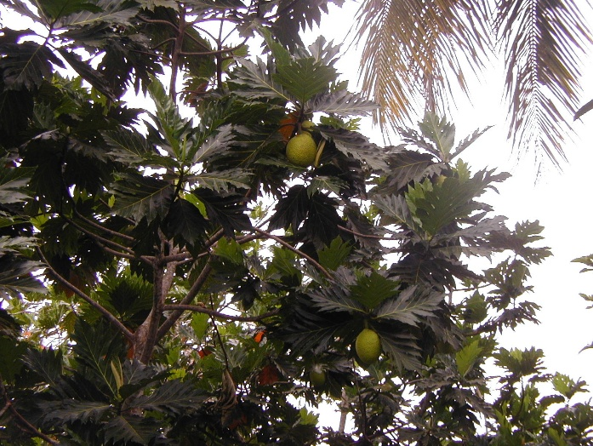

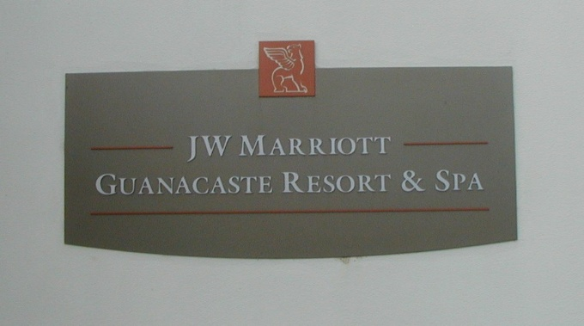
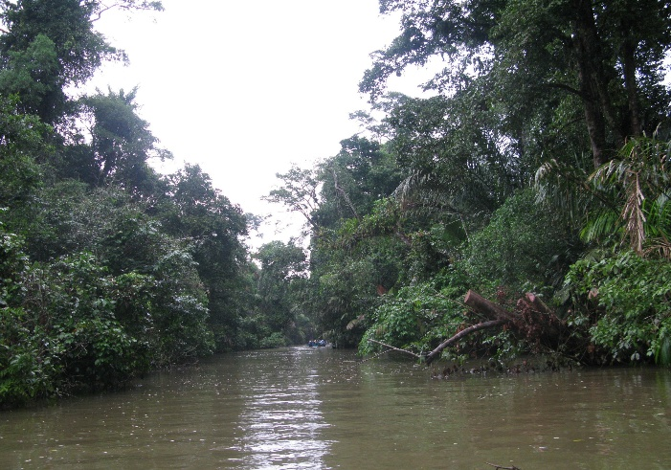

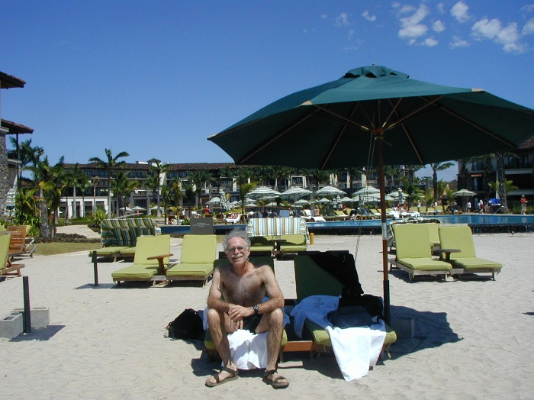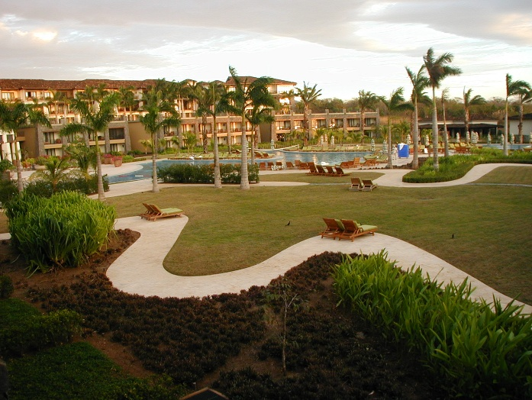
At 07:45, day 9, Friday Feb. 19, we leave JW Marriott (Hacienda Pinilla) situated on the pristine Pacific coast. Before leaving, however, we fortify ourselves with a typical, hearty breakfast of varied fruits. Gucabana with its big seeds, watermelon, pineapple, starfruit, papaya. Eggs & bacon with a crepe honey & chocolate. Then start a 2+ hour drive from Guanacaste to San Jose over dry, deciduous, pampas-like terrain. On our way back to San Jose, we pass through Monteverde (a Quaker community in the 1950s), Pueblo Viejo, & Sarchi with its carts & wheels & artisanal shops. In Monteverde, I have a creamy, tasty pistachio ice cream cone & taste edam & gouda cheese. We cross over the Cordillera.
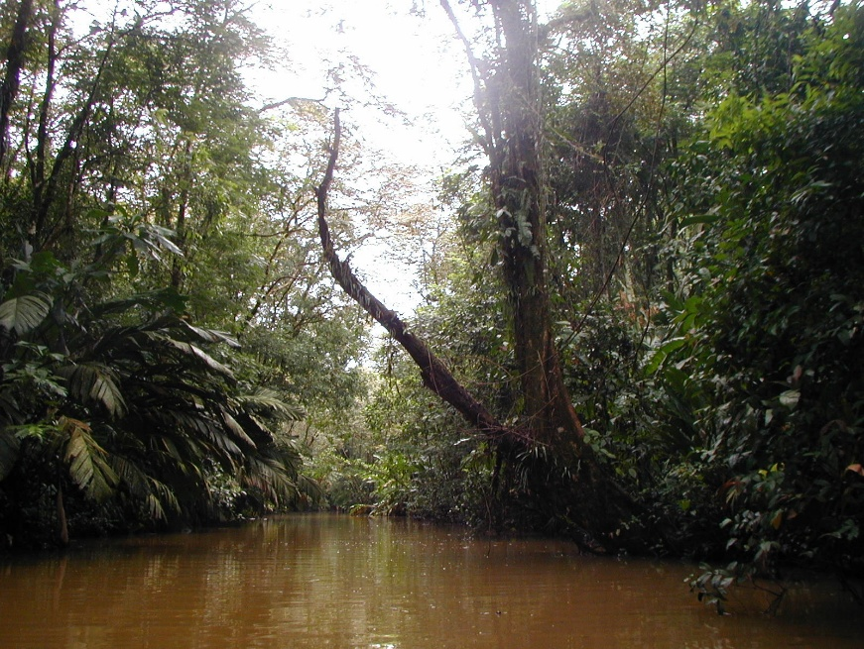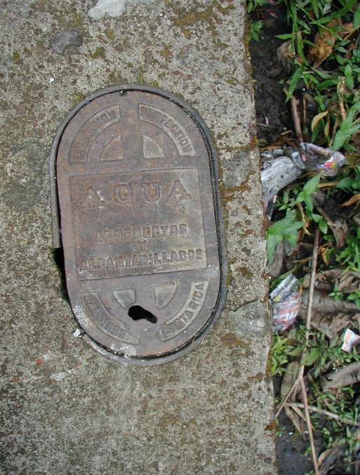

Lunch in Sarchi at a restaurant which happens to be conveniently located next to an irresistible, well-stocked artisanal shop with all sorts of beautiful, colorful crafts. However, prices do seem higher here than for comparable items we found in Guatemala. And, of course, Sherry can't resist buying some things. And I can't resist taking video and pictures. Sarchi is known for its colorful carts & wheels. It is about 45 minutes from San Jose. By 17:45 we are back at the Barceló Palacio, Aurola Hotel. Sherry & I stroll along the walking street past the cathedral. Dinner at 18:30 with entertainment.
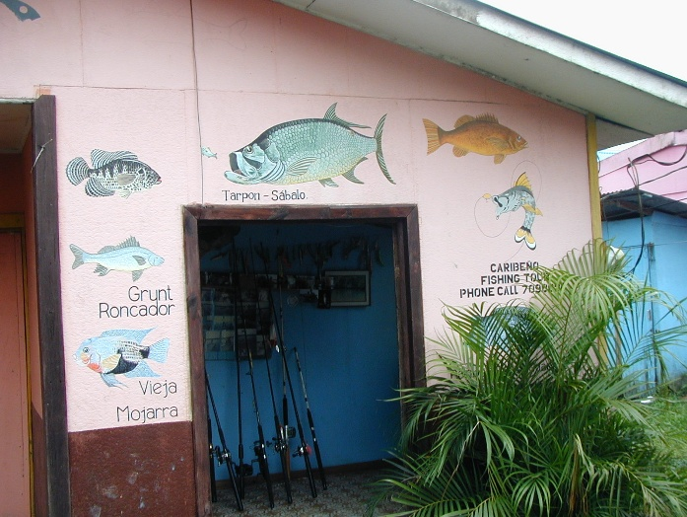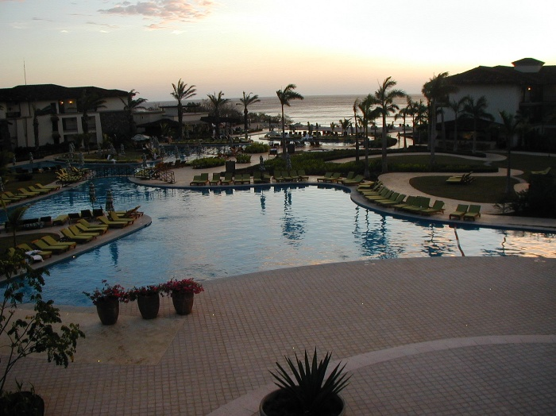

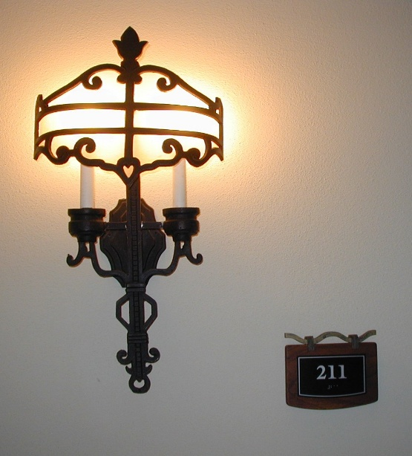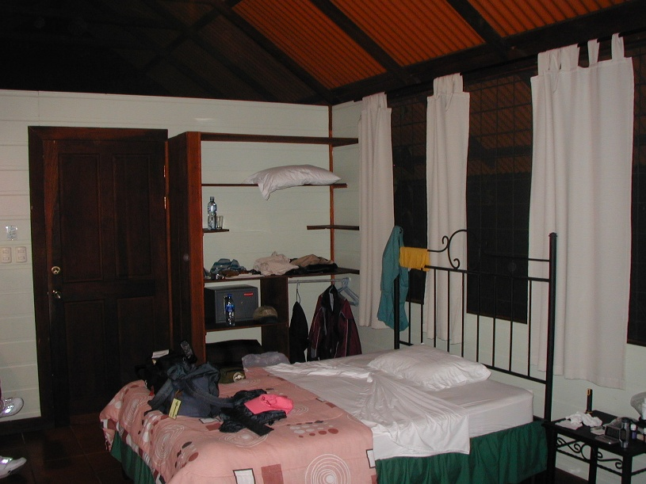

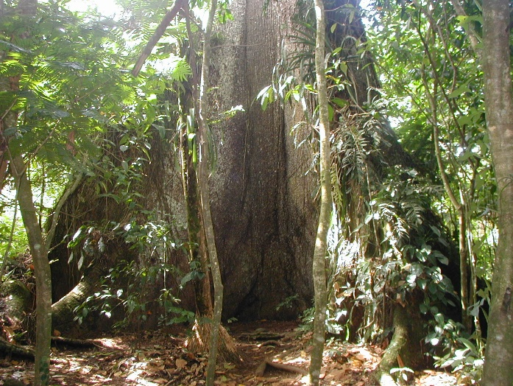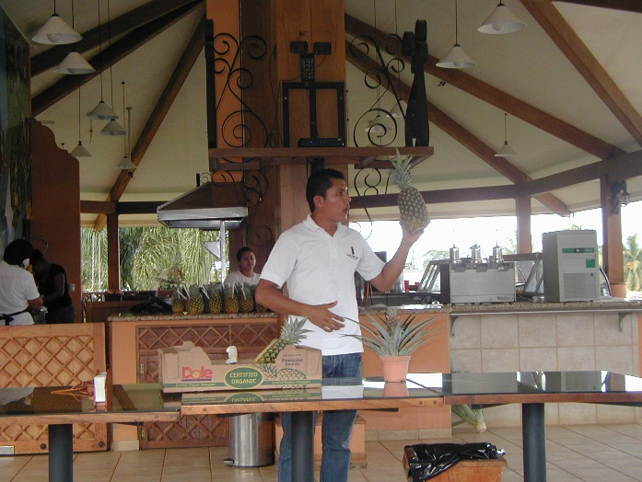

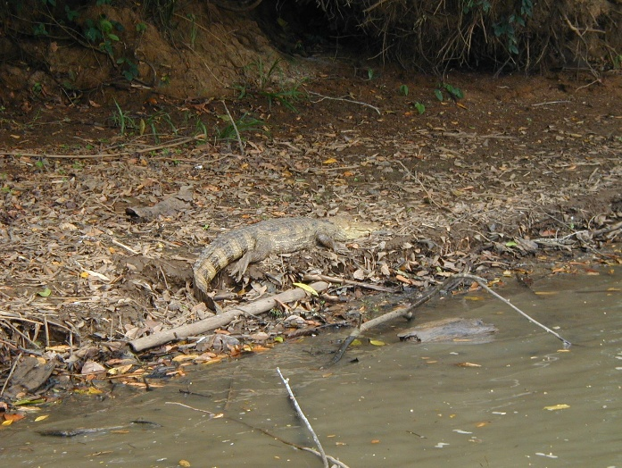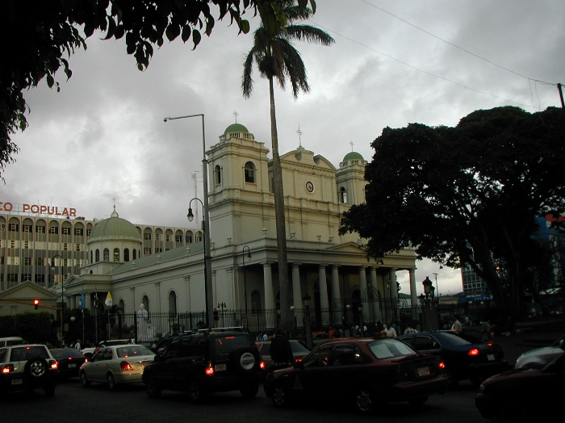

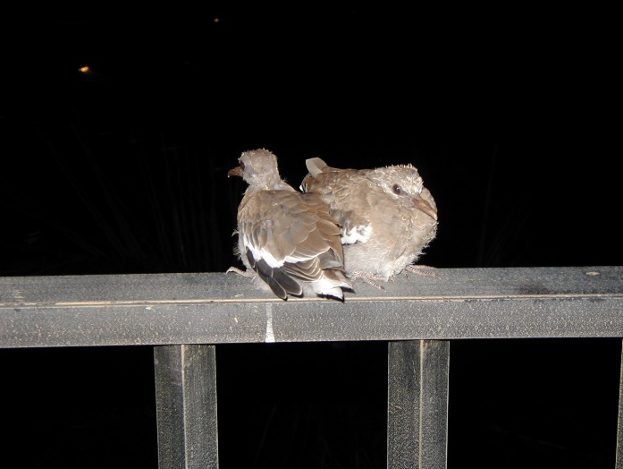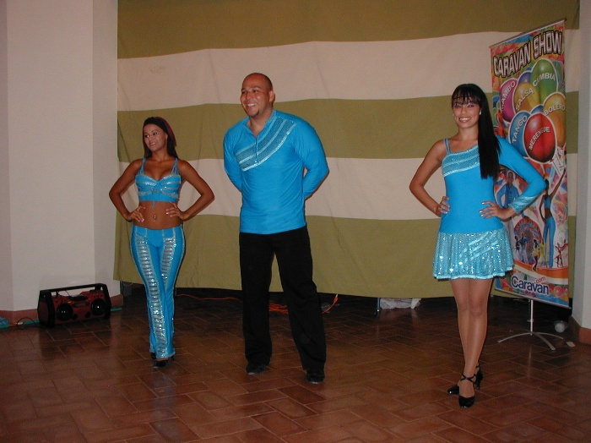

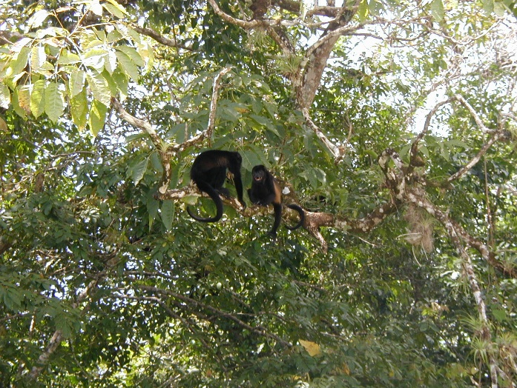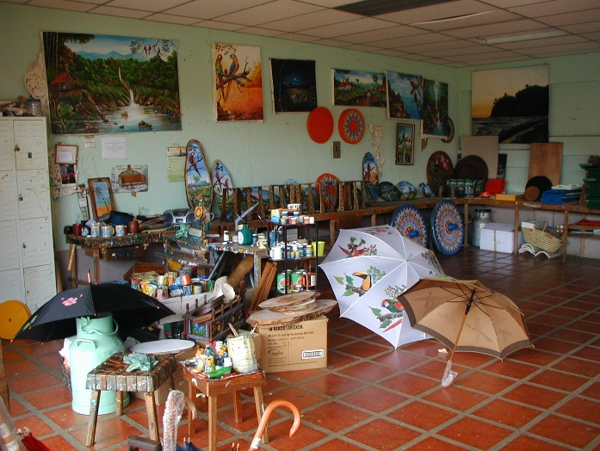

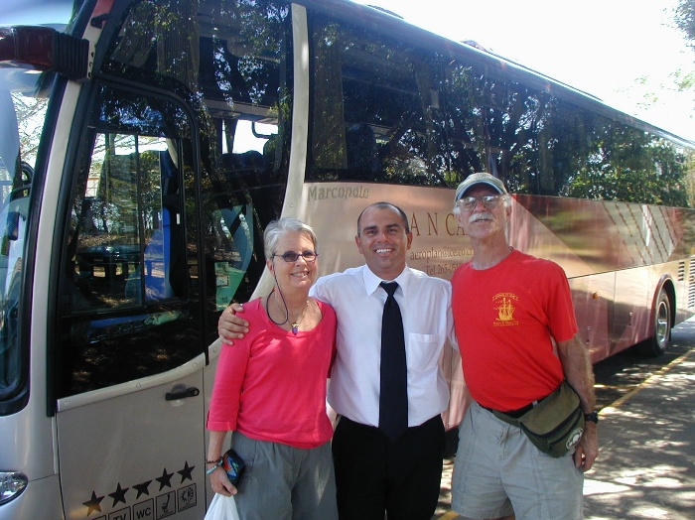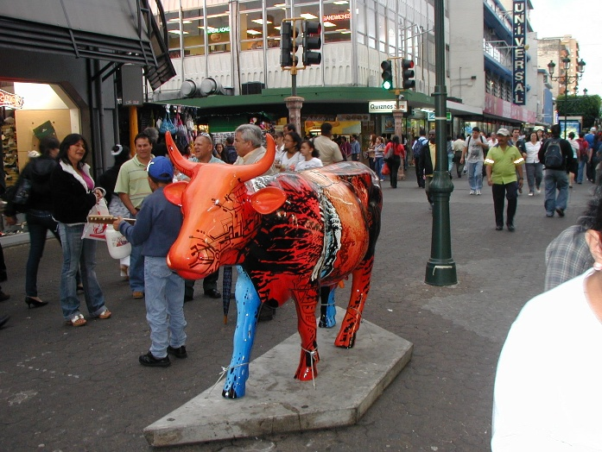
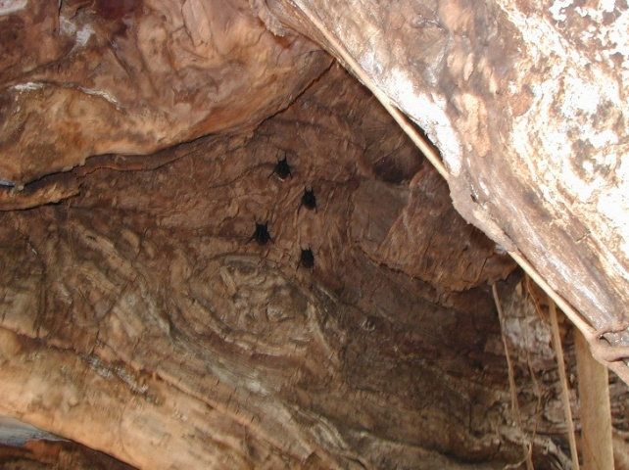
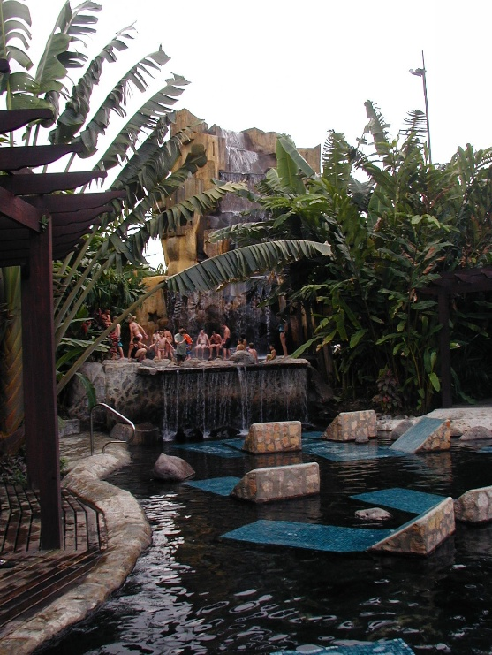
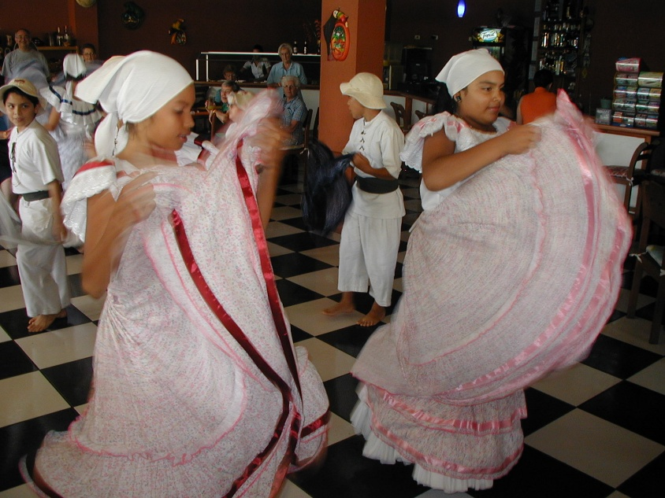
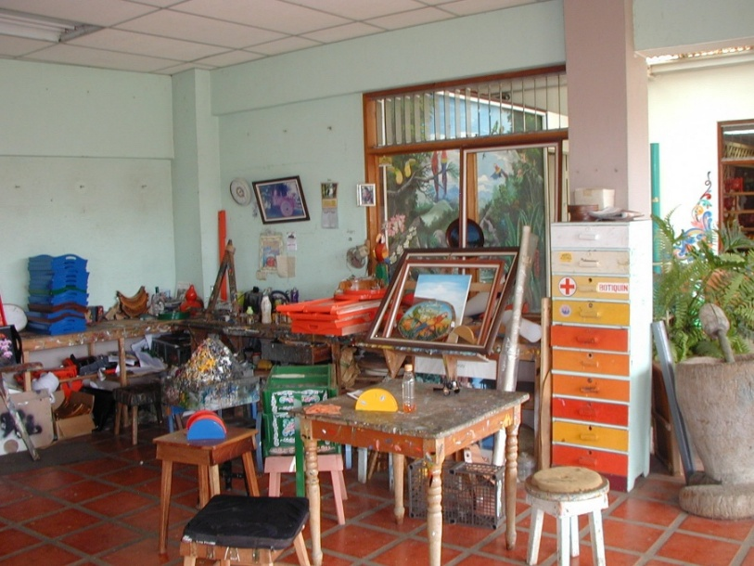
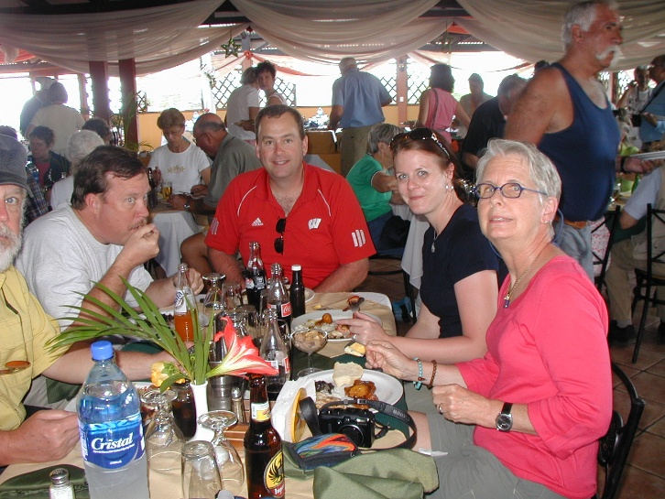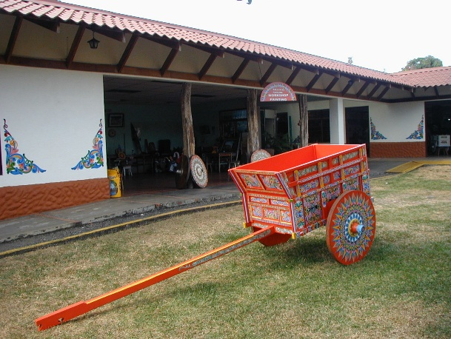

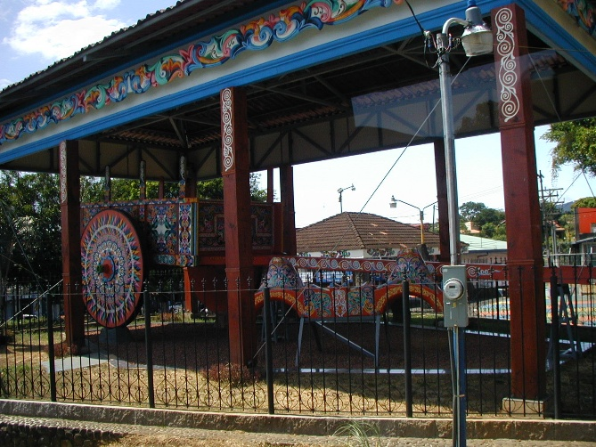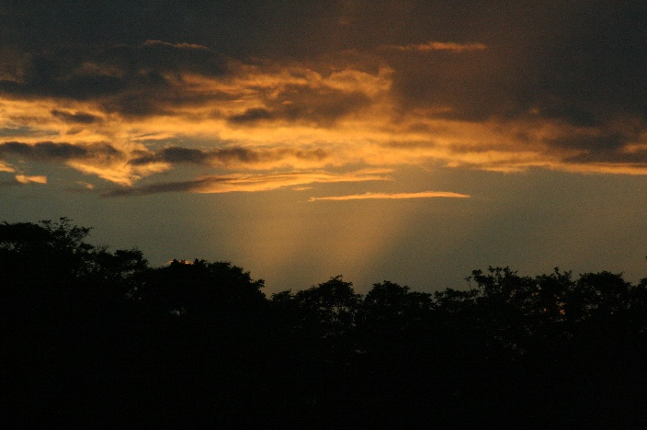

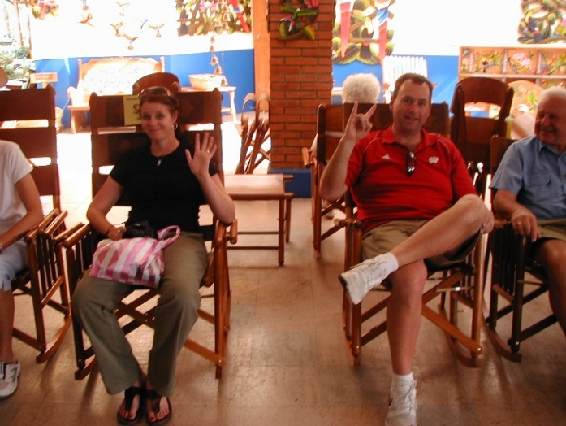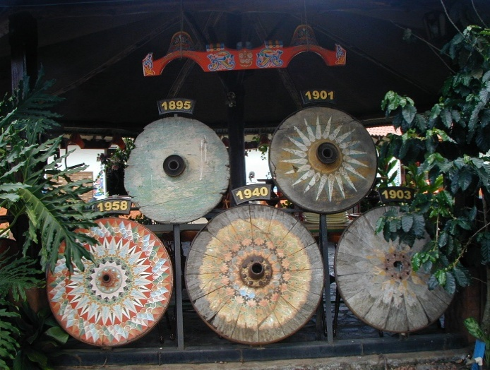
Our last night, we eat in the 17th floor Mirador Restaurant. Exceptional dinner of filet mignon, mashed potatoes & veggies. A show with actors representing different fauna. Butterfly, frog, crocodile, macaw, & more. Piano playing. We sit with Rochester residents Mary Ellen & Wilma, who know CHQ, Carol & Elston. Fun & intimate conversation. Elston shows us a photo of spouse Evelyn (very white) & Debbie 10 & Elston 2. Carol back packs in Yosemite & the Sierra Madres.

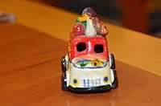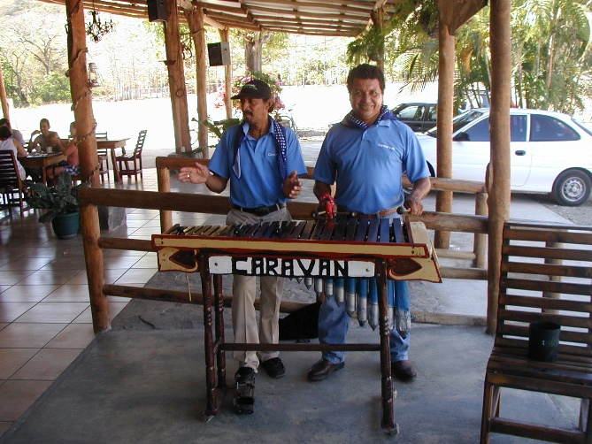

This is it. Day 10, Saturday, February 20, 2010. I give Elston Valentin his gratuity after my morning walk. Driver Franklin got his yesterday. Both were quite good, as was our group. Simpatico. Patient. Cordial. Flowing. No cliques. We leave on TACA airlines at 12:27. As I finish this album in December 2017, we are discussing the same trip for the entire family in December 2018 to celebrate Sherry's 75th.
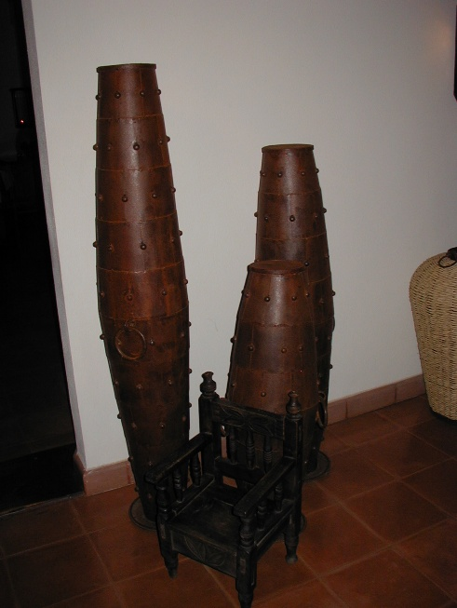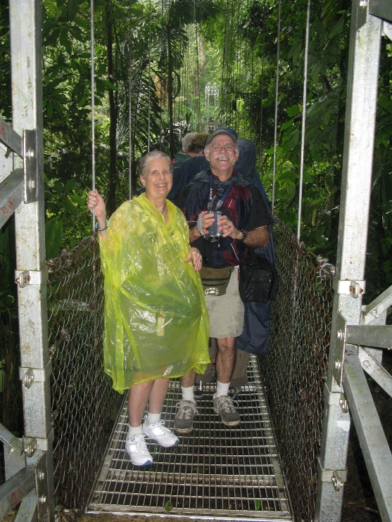
So commonly heard in Costa Rica is the expression "Pura Vida" that captures in two simple words an entire way of life and culture. I also captured much of our tour in 104 minutes of video (DCD # 27).

